Project Report

On

**Healthcare System**

For

**Bitworld Software Solution, Baramati**

Submitted By

Ms. Bhagyashri Atre (03)

Ms. Sujata Lakade (07)

Ms. Mayuri Gosavi (10)

Ms. Sonali Gaikwad (13)

Ms. Amruta Suryawanshi (19)

Ms. Swapnali Joshi (24)

Master of Computer Application

Savitribai Phule Pune University

Vidya Pratishthan’s Institute of Information Technology (VIIT),

(Accredited by NAAC with “A” Grade)

Vidya Nagari, Baramati,

Dist. Pune - 413133

(2020-2021)

**CERTIFICATE**

This is to certify that , Ms. Bhagyashri Atre , Ms. Sujata Lakade , Ms. Mayuri Gosavi , Ms. Sonali Gaikwad , Ms. Amruta Suryawanshi , Ms. Swapnali Joshi of MCA Course(Track – I : Software and Application Development ), SEM – VI has completed their project work titled “**Healthcare System**” , as a part of curriculam during the Academic Year 2020 – 2021.

University Seat No :

Dr. Mayank Kothawade Dr. Sateeshchandra Joshi

**Head of Department In – charge** **Director**

## 

**External Examiner** **Sign of Examiners** :

## 1.______________________ __________________

## 2.______________________ __________________

**Date of Examination :**

**GUIDE CERTIFICATE**

This is to certify that , Ms. Bhagyashri Atre , Ms. Sujata Lakade , Ms. Mayuri Gosavi , Ms. Sonali Gaikwad , Ms. Amruta Suryawanshi , Ms. Swapnali Joshi of MCA Course , SEM – V and VI has successfully completed their project work titled “**Healthcare System**” under my guidance during the Academic Year 2020 - 2021.

Dr. Santosh Parakh

**Project Guide**

**DECLARATION**

We hereby declare that, the project entitled “**Healthcare System**” for “ **Bitworld Software Solution , Baramati**” have completed & written by us. Current project has not previously formed the basis for the award of any degree or diploma or other similar title of this or any other university or examining body.

**Place : Baramati**

**Date :**

Signature Signature Signature

**Ms. Bhagyashri Atre Ms. Sujata Lakade Ms. Mayuri Gosavi**

Signature Signature Signature

**Ms. Sonali Gaikwad Ms. Amruta Suryawanshi Ms. Swapnali Joshi**

**ACKNOWLEDGEMENT**

We take pleasure in presenting our project work. We are thankful to our guide Dr. Santosh Parakh of VIIT and Mr. Sandip Khomane of Bitworld Software Solution , Baramati , who keeps monitoring our project continuously to complete it in time as per the expectations of the course.

“**Ability is of little account without opportunity**” , We wish to thank our In – charge Director **Dr. Sateeshchandra Joshi** , who gave us a very bright learning opportunity , during our course to prove our ability and skills.

We would also like to thank **Dr. Mayank Kothawade** ( Head of Department ) for providing all the necessary facilities at college during the development of this project.

Last but not least we would like to express our heartleft gratitude towards staff members of VIIT , our colleagues and friends for their moral and technical support throughout the duration of the project.

**Our sincere thanks to all**

Ms. Bhagyashri Atre

Ms. Sujata Lakade

Ms. Mayuri Gosavi

Ms. Sonali Gaikwad

Ms. Amruta Suryawanshi

Ms. Swapnali Joshi

**Table of Contents**

| **Chapter No.** | **Topic Name** | | **Page**  **No.** |
| --- | --- | --- | --- |
| **1** | **Introduction** | | 1-4 |
| 1.1 | Company Profile |  |
| 1.2 | Introduction of project |  |
| 1.3 | Existing system & need of the system |  |
| 1.4 | Limitations of Existing system |  |
| **2** | **Proposed System** | | 29-45 |
| 2.1 | Problem Statement/s |  |
| 2.2 | Product Position Statement/s |  |
| 2.3 | Product Overview |  |
| 2.4 | Technologies Used |  |
| 2.5 | Summary of Capabilities |  |
| 2.6 | Assumptions & Dependencies |  |
| 2.7 | Objectives of the Proposed System. |  |
| 2.8 | Functional requirements / Salient Features |  |
| 2.9 | Non functional requirement/s |  |
| 2.10 | Stake holder Summary |  |
| 2.11 | User Summary |  |
| 2.12 | Scope of the System |  |
| 2.13 | Module Specification |  |
| 2.14 | Operational Environments |  |
| **3** | **Requirement Determination & Analysis** | | 53-67 |
| 3.1 | Fact Finding Methods |  |
| 3.2 | Feasibility Study |  |
| **4** | **System Analysis and Design** | |  |
| 4.1 | Use Case Diagram |  |
| 4.2 | Sequence Diagram |  |
| 4.3 | Activity Diagram |  |
| 4.4 | Class Diagram |  |
| 4.5 | Object Diagram |  |
| 4.6 | Module Hierarchy Diagram |  |
| 4.7 | Component Diagram |  |
| 4.8 | Deployment Diagram (In case of web development) |  |
| 4.9 | Interface Diagram ( In case of WAP and Embedded Systems ) |  |
| 4.10 | Web Site Map Diagram ( In case of Web Site ) |  |
| 4.11 | User Interface Design (Screens etc.) |  |
| 4.12 | Table specifications (In case back end is a database) |  |
| 4.13 | Data Dictionary |  |
| 4.14 | Test Procedures and Implementation (including testing details) |  |
| **5** | **User Manual** | |  |
| 5.1 | User Manual |  |
| 5.2 | Operations Manual / Menu Explanation |  |
| 5.3 | Program Specifications / Flow Charts |  |
| **6** | **Benefit, Limitations and Conclusion of the system** | |  |
| 6.1 | Benefits of the system |  |
| 6.2 | Limitations of the system |  |
|  | 6.3 | Conclusion of the system |  |
| **7** | **Proposed Enhancement** | |  |
| **8** | **Self-Learning from Project (Overall Experience)** | |  |
| **Bibliography** | | |  |
|  | I | Books / Journals |  |
|  | II | Links of websites referred |  |
| **Annexure – I** User Interface Screens | | |  |
| **Annexure – II** Output Reports with data ( if any ) | | |  |
| **Annexure – III** Sample Program Code / Project Demo (which will prove sufficient development is done by the student ) | | |  |

**Chapter 1**

**INTRODUCTION**

**1.1 Company Profile :-**

“**Bitworld Software Solution, Baramati**” is a customer focused and technology driven **Software Development Company** in Baramati, Pune providing product enterprise Software/Application development services that help client in crafting holistic value for their software development efforts.

**Services Provided By Company :**

Web Application Development

Mobile App Development

SEO

**1.2 Introduction :-**

**“Healthcare System”** is a web based system to manage the Patients , Doctors , Pharmacy and Laboratories in a single platform.

A Healthcare System is essentially a computer system that can manage all the information to allow health care providers to do their jobs effectively. It provides all the facilities related to our health. There are different Hospitals, Doctors, Pharmacy, Laboratory which provide facilities to the patient online.

In this system patient want to take appointment of a particular specialist doctor and then make consultation with given appointment time. Patient can order the medicines via upload the prescription and also do the lab test when the test can be compulsory told from the doctor.

This system provides Online / In-clinic consultation to the patient , provide medicines delivery at their doorstep and collect the test sample of a particular patient at their home / office. Patient can also buys the wellness product in this system.

Healthcare System includes registrations of patients, doctors, Pharmacists, Laboratories. Storing their details into the system and also computerized payment of a patients, pharmacy and labs. This system includes a search facility to know the nearby hospitals, specialist Doctors, Medical stores and laboratories.

**1.3 Existing System :-**

Healthcare is a very important part of our society

• In existing system there is hardly any medical service available in remote locations.

• Persons needing medical services often need to travel long distances.

• Patients and doctors are hardly to communicate with each other’s and also patients

had to wait for a long time to communicate to the doctor.

• Not maintain 24/7 hours availability in existing system.

• Doctors are not available instantly to patient in a given particular time slots.

• Facing the delay problems of lab test reports.

**1.3.1 Comparison of existing system : -**

|  |  |  |  |
| --- | --- | --- | --- |
| **Features** | **Proposed** | **1mg.com(Existing)** | **Pharmeasy.com(Existing)** |
| Member Registration | Yes | Yes | Yes |
| Member Log In | Yes | Yes | Yes |
| Profile Management | Yes | Yes | Yes |
| Address Verification | Yes | No | No |
| Location | Yes | Yes | Yes |
| Consultation | Yes | Yes | No |
| Health Locker System | Yes | No | No |
| Online buy & sell facility | Yes | Yes | Yes |
| Content Search nearby area wise | Yes | Yes | Yes |
| Status of complaint | Yes | No | No |
| Give online notification to patient for the diet and tablets time. | Yes | No | No |
| Add family members | Yes | No | No |

* **Need of Healthcare System :-**

Electronic medical records improve quality of care, patient outcomes, and safety through improved management, reduction in medication errors, reduction in unnecessary investigations, and improved communication and interactions among providers, patients, and other providers involved in healthcare system.

**1.4 Limitations of Existing system :-**

The following are some limitations which occurred in existing System :

• In existing system all fields like doctor , patient , Pharmacy and laboratory not in single

root.

• Health-Locker (Stored documents online) system not provided.

• In existing system we can take treatment only for ourselves.

• Doctors are not available instantly according to the time slots selected by the patient.

System keep rescheduling appointments and no doctors actually shows up.

• In existing system there is hardly any medical service available in remote locations.

**Chapter 2**

**Proposed System**

**2.1 Proposed system :-**

* In this system we serve searching nearest doctors, Pharmacist and Laboratory facility to the patients.
* Patient connect with the specialized doctor via message and video / voice calls. We provide the facility to the patient he / she also add a family member for appointment,

consultation and lab test.

* We provide in-clinic consultation to the patient by taking an appointment of a specialized doctors in their given time slots.
* We provide quickly service of products / medicines delivery to the patient

in their given time.

**2.2 Problem Statement :-**

* **Problem statement 1**

|  |  |
| --- | --- |
| The problem of | Lack of doctor’s availability |
| Affects | Patient |
| The impact of which is | System not works properly to visit a patient and solve their problem. |
| A successful solution would | 1. Many doctors to consult a patient.  2.Manage a doctor’s time slot. |

* **Problem statement 2**

|  |  |
| --- | --- |
| The problem of | Medical History of Patient |
| Affects | Doctor, Patient |
| The impact of which is | 1.They are not able to diagnostic disease of patient.  2.Patient not recover easily. |
| A successful solution would | Maintain all records in health locker which is provided by system to doctor and patient. |

* **Problem statement 3**

|  |  |
| --- | --- |
| The problem of | Delay in lab reports |
| Affects | Patient, Doctor |
| The impact of which is | Reports were not received as per the time given to the patient. |
| A successful solution would | We give facility to provide a lab report in given time slot. |

* **Problem statement 4**

|  |  |
| --- | --- |
| The problem of | Lack of products quantity and quality issue |
| Affects | Pharmacist, Patient, Doctor. |
| The impact of which is | The patient did not get the quality and quantity of medicine as he/she want and also delay to receiving the product. |
| A successful solution would | We provide facility to deliver a product within given time slot. |

* **Problem statement 5**

|  |  |
| --- | --- |
| The problem of | In existing system there is hardly any medical service available in remote locations. Persons needing medical services often need to travel long distances. |
| Affects | Patient |
| The impact of which is | Patient does not get a medical service in remote area. |
| A successful solution would | In our system we track a patient address and provide a medical service in remote area. |

* **Problem statement 6**

|  |  |
| --- | --- |
| The problem of | Not maintain 24/7 hours availability in existing system. |
| Affects | Patient. |
| The impact of which is | Patient not solve their problems within a given slot. |
| A successful solution would | System available in 24/7. |

**Product Position Statement :-**

|  |  |
| --- | --- |
| For | Patient, Multi-Specialty Hospital, Doctors, lab and Pharmacist. |
| Who | Management as well as the staff included such as doctors, delivery system, lab technicians, Pharmacist etc. will be able to available the services |
| Health Care System | Website of Multispecialty hospital. |
| That | Provide various services in home |
| Unlike | Delay Delivery.  Doctors are not available on time.  Quality products are not available on time. |
| Our product | Data transfer can be made from one department to another.  Medical history helps in diagnosing the patients on the basis of previous medical reports.  We provide a various facility to patient. |

**Product Overview :-**

Health Care System is a web-based system provide hospital related facilities to patient. It provides online consultation of a specialized doctors to the patient. And in-clinic consultations through booking appointments at their given time slots. It provides booking lab tests facility for patients in just within a minute. It also provide medicines and wellness products online to the patient.

**Product Perspective :-**

Health Care System is dependent System on the third-party payment gateways for the payment transactions and also on the SMS gateways for the SMS notifications.

**Technologies Used :-**

* For web based system –

**HTML5**

It is used for creating web pages and web applications.

**CSS**

It allows web designers greater control over the web pages.

**Bootstrap4**

A UI (user interface) framework for building with HTML / CSS / JavaScript.

**JavaScript**

This used by all web browsers, Meteor, and lots of other frameworks.

**JQuery**

It is just a tool to make implementing what you want to do easier.

**PHP**

PHP is a widely-used, open source scripting language.

**MySQL (Database)**

MySQL is an open-source relational database management system

# Summary of Capabilities :-

|  |  |
| --- | --- |
| **User Benefits** | **Supporting Features** |
| * The patient can know about the offers, deals, packages, membership with message alert. | * The system provides the real time offers to the patients, lab testing packages, doctor consultant membership to the user. Message sent to the mass amount of people instantly. |
| * Data Security. | * The system provides the facility of health locker. |
| * Secure payment transactions for patient. | * The world class payment gateways are used by the system. |
| * Patient connect with doctor instantly. | * Provide facilities of video calling and audio calling or online consultation via chat. |
| * Patient easily find out the nearest hospitals and laboratories. | * System provides nearest hospitals and laboratories. |
| * The patient can get his product order or laboratory report at home. | * System provides home delivery and home sample collection facilities to user. |
| * System provides alerting message related to daily diet plan and daily medicine routine to the patient. And also, user registration done through Mobile OTP. | * SMS facility |
| * Doctors or medical stores or laboratories are Authorized or not confirmed through mail notification, SMS or phone call. | * Confirmation and Notification facility. |
| * Patient buy medicine or well product. | * Online purchase facility. |

**Assumptions :-**

* Login name and password secure for access to the system.
* Hardware never fails.
* All interfaces to the system
  + Every input (processing) into the system
  + Every output (response) from the system
  + All functions performed by the system
* The users have sufficient knowledge of computers.
* The database must be present on the system on which the system is installed and must have authorities to handle the system.
* The administrator and user must have proper login id and password so that only authorized persons and user can have proper access to the system.

**Dependencies :-**

* The Health Care system is dependent on modules of the system will depend on each other.
* Each Member has own username and password which is verified by system.

**Objectives of Proposed System :-**

• To provide convenient and user-friendly services.

* To provide online visiting platform for doctors, patient, pharmacist and laboratory operator.
* To provide the facility to patient he/she easily connected with doctor via voice /video call or chat.
* To provide essential medical services online to user location.
* To reduce the time-consumption.
* To provide cost effective and easily manageable technology.
* To provide the better services to the patient.
* To provide doorstep delivery services for medicine / products.
* To provide collect test sample at patient home / office.
* To Provide 24*7 availability

**Functional requirements / Salient Features :-**

* + 1. Doctor
* Registration
* Login
* Create / View / Update Profile
* Add hospital services.
* Manage their time slot.
* Apply for leave.
* Chat with a patient in a given time slots (Voice call / Video).
* Understand the symptoms of a particular patient via chat.
* Give the valid prescription to the patient.
* Suggest lab to patient for the lab test.
* Suggest in-clinic consultation to the patient.
* Save important documents in health locker.
* Receiving online payment from patient.
  + 1. Patient
* Registration
* Login
* Create/View/Update Profile.
* Chat with a doctor in a given time slots (Voice call / Video).
* Give in-clinic appointment.
* Add multiple family members for booking appointment.
* Search nearest medicals and order medicines to the pharmacist.
* Upload prescription to the pharmacist for medicines.
* Check medicine.
* Choose lab test packages for test (In lab / Collect the test sample from home / Office).
* Check lab report.
* Online payment (Doctor, Pharmacist, lab).
  + 1. Laboratorian
* Registration
* Login
* Create/View/Update Profile.
* Add tests and packages.
* Add multiple tests into package.
* Add their available time slots for test.
* Apply for leave.
* Add availability of lab test (In lab / Home collection).
* Take prescription from patient about the lab test.
* Take patient details.
* Search home collection agent via pin-code for collecting the test sample from patient.
* Generate the test reports in a given time slots.
* Upload the reports to the patient.
* Online Payment.
  + 1. Pharmacist
* Registration
* Login
* Create/View/Update Profile.
* Add medicine and products.
* Add their available time slots.
* Apply for leave.
* Take a Uploaded Prescription from the patient.
* Make a confirmation call of receiving prescription with the patient and take the patient details.
* Receiving order from patient (Medicine / Wellness product).
* Search delivery agent via pin-code for delivering medicines / wellness products to patients.
* Make a confirmation call for checking the successful delivery of medicines / wellness products.
* View replacement orders of medicines/wellness products.
* Online Payment.
  + 1. Delivery Boy
* Registration
* Login
* Create/View/Update Profile
* Add location.
* Check upcoming delivery of medicines / wellness products from pharmacist.
* Pick up the order from particular location.
* Delivered order to a particular location.
* Make a confirmation call with the pharmacist.
* If patient needs to replace the medicines or products, then delivery boy will be redelivering that product or medicine to the patient.
  + 1. Pickup Boy
* Registration
* Login
* Create/View/Update Profile
* Add location.
* Collect the prescription from the laboratorian related to the patient lab test.
* Collect the test sample from patient and delivered to the laboratorian.
  + 1. Accountant
* Login
* Manage all payment.
* Manage doctor consultation fee.
* Manage payment of a patient.
* Manage Laboratorian fee.
* Manage delivery boy and home collection(pickup boy) payment.
* Manage pharmacist payment.
  + 1. Manager
* Login
* Verify Doctor/Laboratorian/Pharmacist and provide authentication to them.
* Manage the specialized doctors list and there hospitals as per locations.
* Manage the various pharmacist list as per locations.
* Add filters of medicines as per there category, brand, price, quality and availability of their quantity.
* Manage the test and packages and also their price.
  + 1. Admin
* Login
* Verify Doctor/Laboratorian/Pharmacist and provide authentication to them.
* Add role and services.
* Manage all users.
* Manage the specialized doctors list and there hospitals as per locations.
* Manage the various pharmacist list as per locations.
* Add filters of medicines as per there category, brand, price, quality and availability of their quantity.
* Manage the test and packages and also their price.

**Non-Functional Requirement :-**

# 2.9.1 Stakeholder and User Descriptions :

**Scalability**

Multiple users can access the system at time to maintain the hospital activities.

**Availability**

The system is made available to the user all the time.

**Reliability**

The system will automatically prompt the user if an incorrect input is being made.

**Performance**

Depends on the speed of the internet to get the faster access to the system.

**Security**

Every user is provided with their respective username and password.

**Maintainability**

Proper documentations is made to understand the overall interface of system.

**User friendly**

System is very easy to use and user friendly.

**Stakeholder Summary :-**

|  |  |  |
| --- | --- | --- |
| **Name** | **Represents** | **Role** |
| System Administrator | Owner of the website (Higher authorized person in application). | Controls all the activities of the site. |
| Manager | Data Analysis and Presentation in text and graphical format. | Manage the system. |
| Accountant | Represent payment option to the user. | Handle all type of payment. |
| Delivery boy | Create profile for making delivery of medicines/ products. | Delivered the medicines/products to the patient doorstep. |
| Pickup boy | Create profile for collect the test sample from the patient. | Collect the test sample and delivered to laboratory. |

**User Summary :-**

|  |  |  |
| --- | --- | --- |
| **Name** | **Description** | **Stakeholder** |
| Patient | Online Consultation with doctor,  Purchase Medicine/Products,  Booking online lab test. | Only registered patients allow for the consultation with doctor. |
| Pharmacist | Provide doorstep Medicines / Wellness Products. | Certified pharmacist can allow in system and also aware about the fake medicines/ products (i.e. Medicine quality). |
| laboratorian | Take a lab test. | Certified labs can allow in system. |
| Doctor | Provide Online Consultation/ In-Clinic consultation to the patient. | Certified specialist can allow in system for consult to patient. |

**Scope of the system :-**

* Provide Online / In-clinic consultation to the patient.
* Patient can book appointment for in-clinic consultation.
* Provides the facility of online purchasing medicines / wellness products.
* Patient can book lab tests or lab packages online.
* Lab tests can be done at the patient home / office location.
* To provide the facility to the patient of searching nearest hospitals and doctors.
* To provide the facility of health locker to the patient doctor for save their important documents online securely.

**Module Specification :-**

**User of the system –**

Patient

Doctor

Pharmacist

Laboratorian

**Operational Environment :-**

|  |  |  |  |  |  |  |  |  |  |
| --- | --- | --- | --- | --- | --- | --- | --- | --- | --- |
| |  |  | | --- | --- | | **Hardware interface** | **Requirements** | | Processor | Intel core i5 | | RAM | 1 GB and above | | Hard disk | 1. GB | | |
| **System requirements -**   |  |  | | --- | --- | | **Software** | **Requirement** | | Operating system | Windows operating system | | Browser | Chrome, Mozilla Firefox, IE | | Front end | HTML5, CSS, JS, jQuery, AngularJS, Ajax, Bootstrap | | Back end | MySQL Server | | Web server | XAMPP, Apache Server | | |
|  |  |
|  |  |
|  |  |
|  | |
|  |  |
|  |  |
|  |  |
|  |  |

**Chapter 3**

**Requirement Determination**

**&**

**Analysis**

**Fact Finding Methods :-**

Fact finding is process of collection of data and information based on techniques which contain sampling of existing documents, research, observation, questionnaires, interviews, prototyping and joint requirements planning.

* **Record inspections or reviews**

Basic records like the reports, bills, policy manuals, regulations, standard operation procedures etc. can be used for better understanding the system. Here we use record review technique to analyze the system properly. We studied the traditional record keeping system using the previous records.

• **Observation**

This is a skill which the analysts have to develop. The analysts have to identify the right information and choose the right person and look at the right place to achieve his objective. He should have a clear vision of how each departments work and work flow between them and for this he should be a good observer. We observes the overall working of the doctors , pharmacists , laboratorians.

• **Questionnaires**

Here the analysts can collect data from large groups. Questionnaires could be Open-ended or Close questionnaires. Open-ended questionnaires are used to learn feelings, opinions, general experiences on process detail or problem. In it, questions are answered in their own words. Where as in closed questionnaires a set of prescribed answers are used and specific response have to be selected. This is a costly affair as the questions should be printed out. Questionnaires like,

1. How you manage the IPD and OPD in hospital?

2. What about the appointments?

3. How can we manage the inventory and accounting of hospital?

**Feasibility Study** :-

1. Financial Feasibility –

This is related to economic feasibility but is different. When undertaking a project, the financing for the project has to be secured by the project management. This brings into question whether the project is credit-worthy and whether loans are available to finance projects of that nature

2. Managerial Feasibility –

Managerial feasibility establishes the kind of project management structure to be implemented to ensure that all aspects of the project are completed according the design and within the specified time.

3. Market Feasibility –

Starting up, a market feasibility study is needed to ensure that the product or business is something that people want. The target demographic has to be established and the product centered on their needs and what would ensure the best outcomes financially.

**Chapter 4**

**System Analysis**

**&**

**Design**

**Use Case Diagram :-**

1. Doctor Use Case

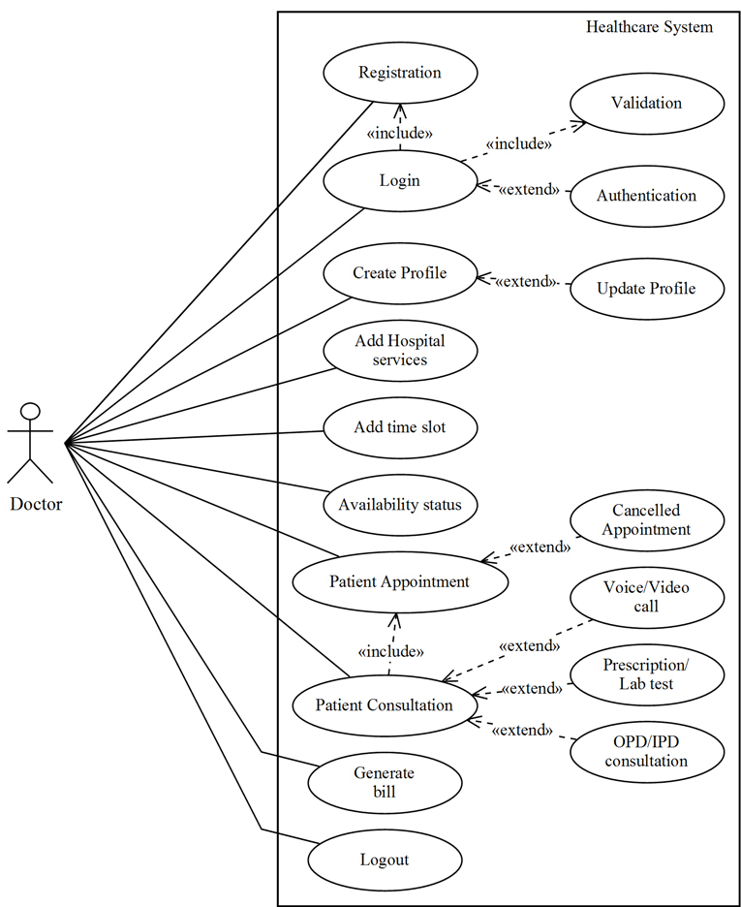

1. Pharmacist Use Case

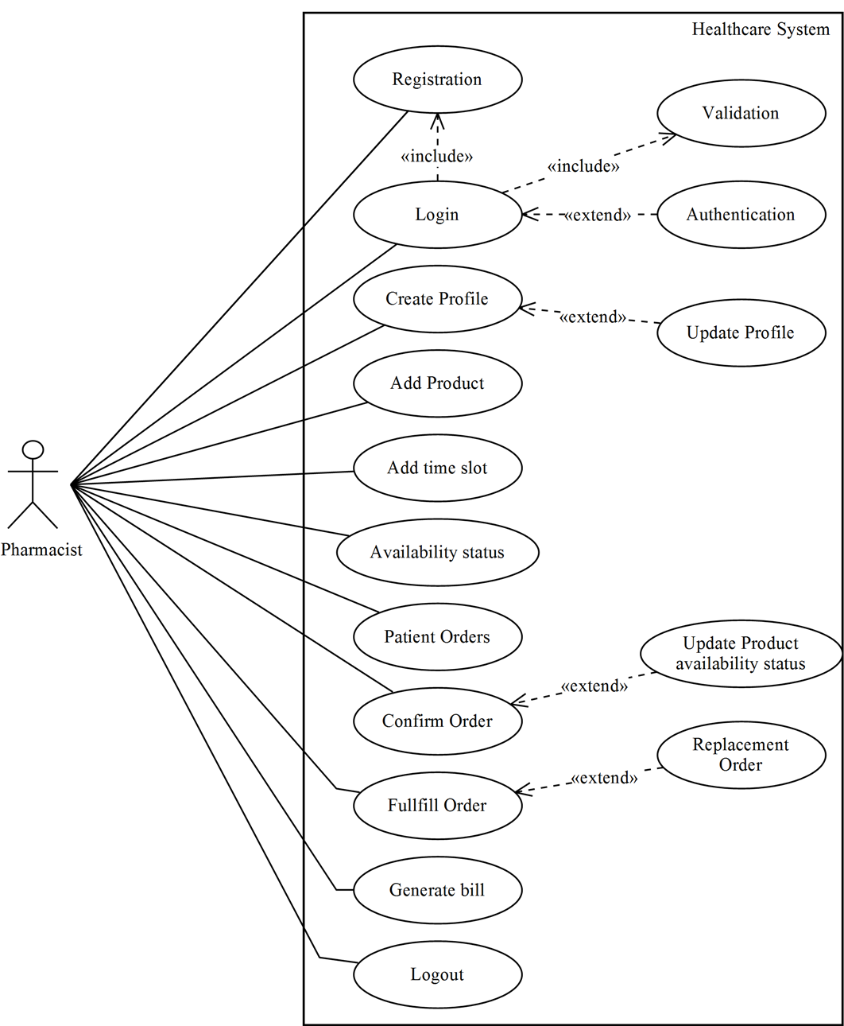

1. Laboratorian Use Case

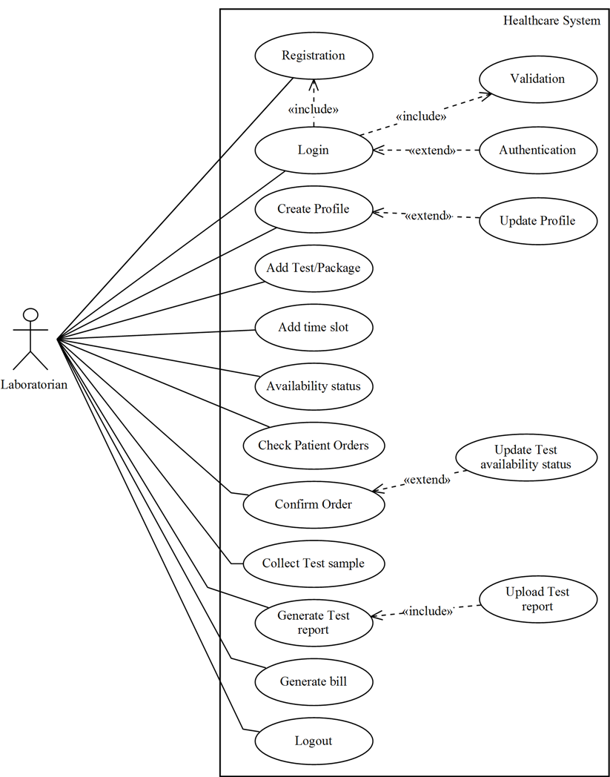

1. Delivery / Pickup boy Use Case

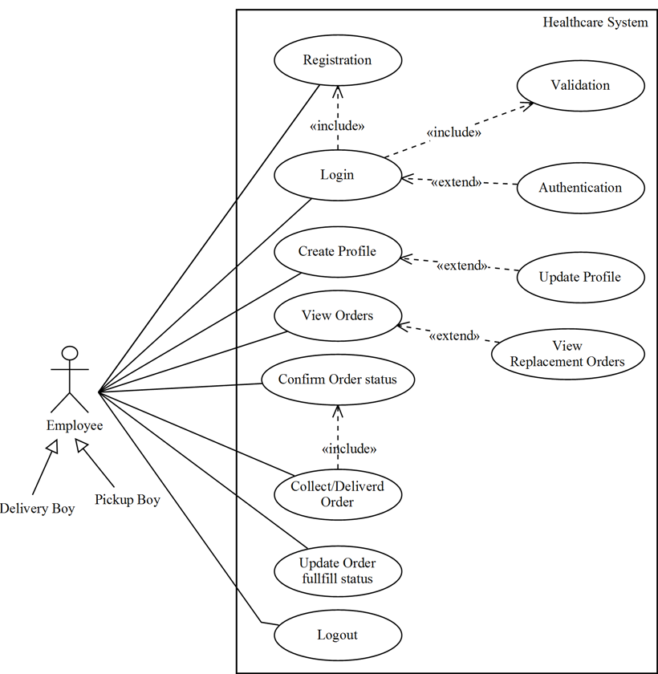

1. Manager Use Case

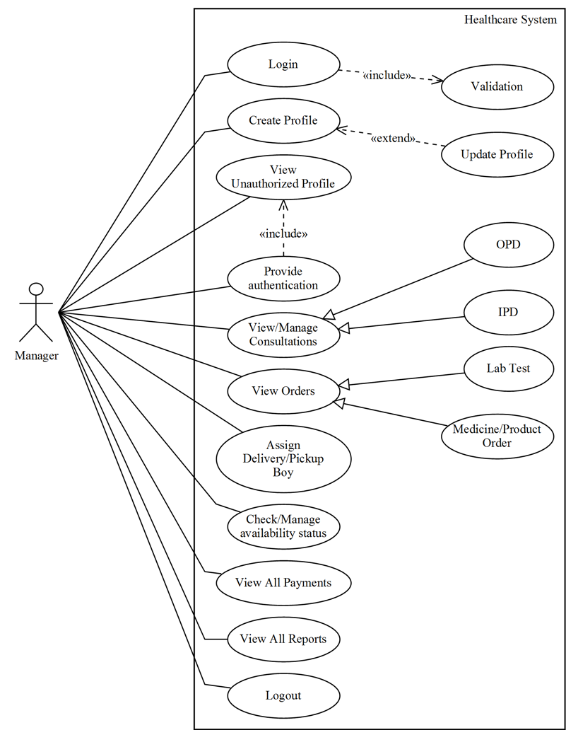

1. Admin Use Case

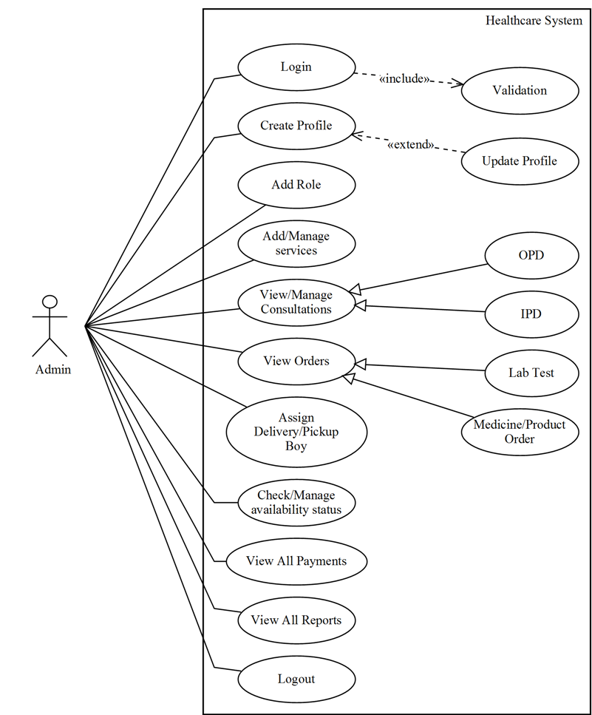

* **Sequence Diagram :-**
  + - 1. Doctor Sequence Diagram

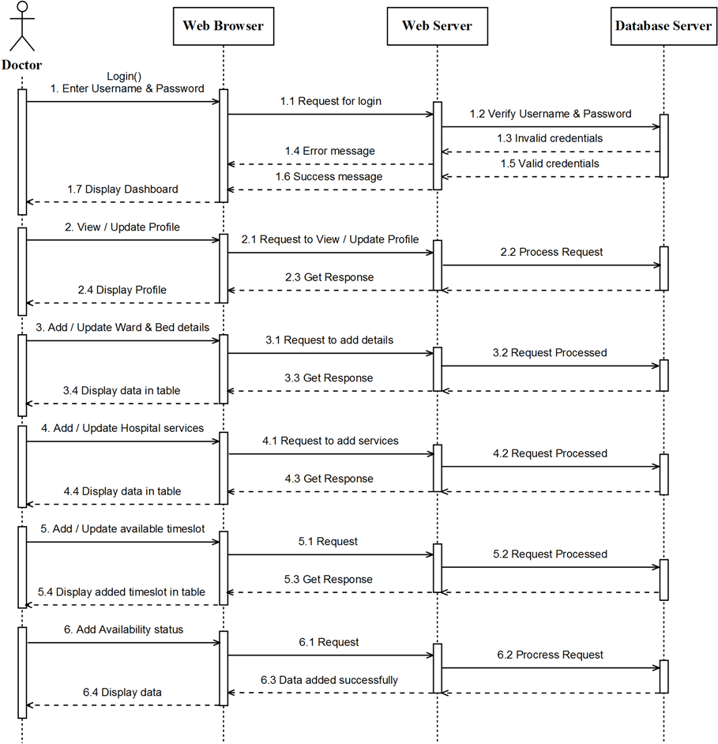

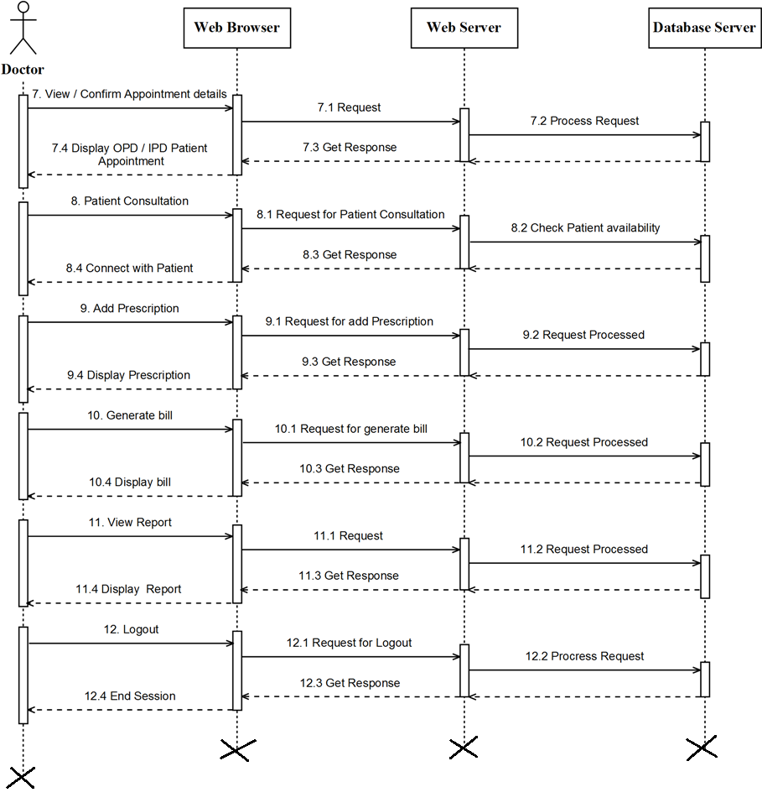

* + - 1. Pharmacist Sequence Diagram

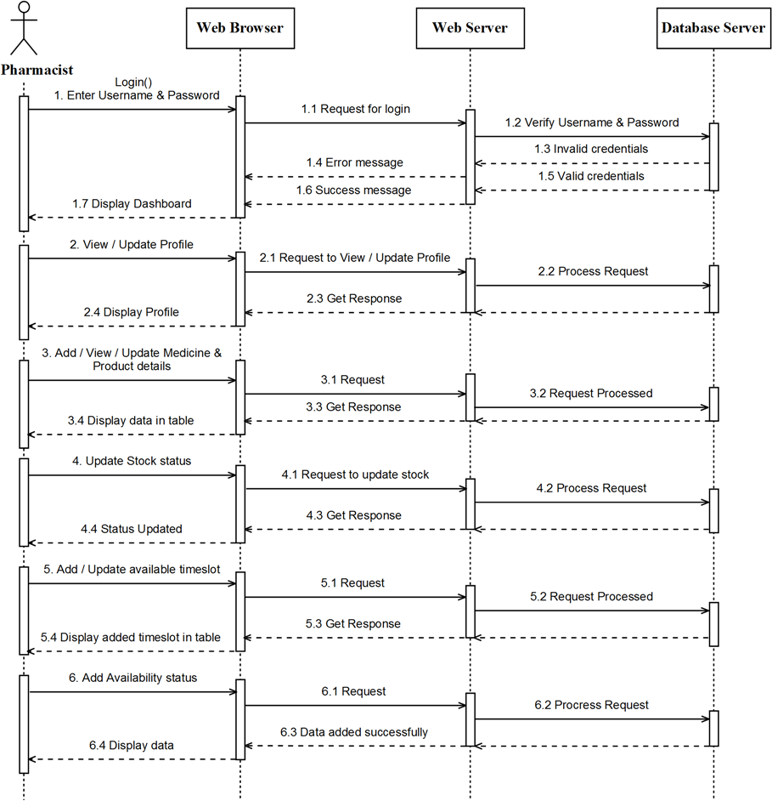

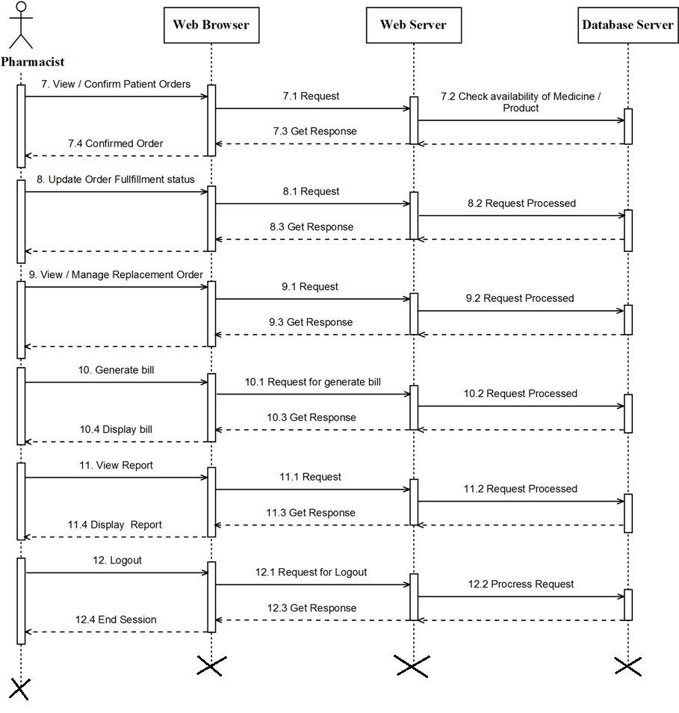

* + - 1. Laboratorian Sequence Diagram

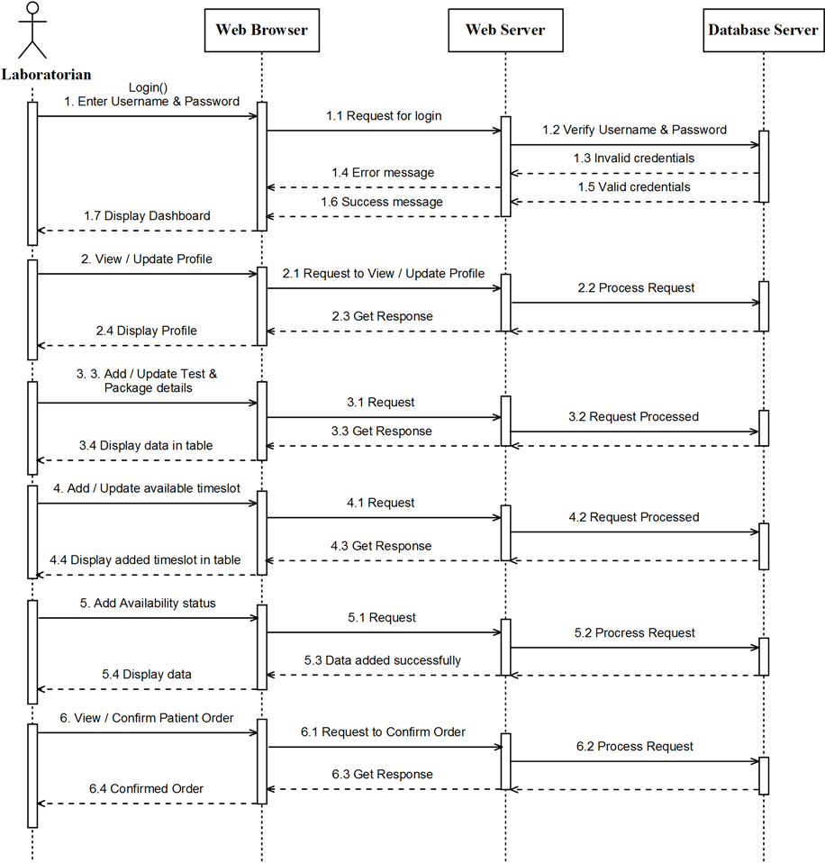

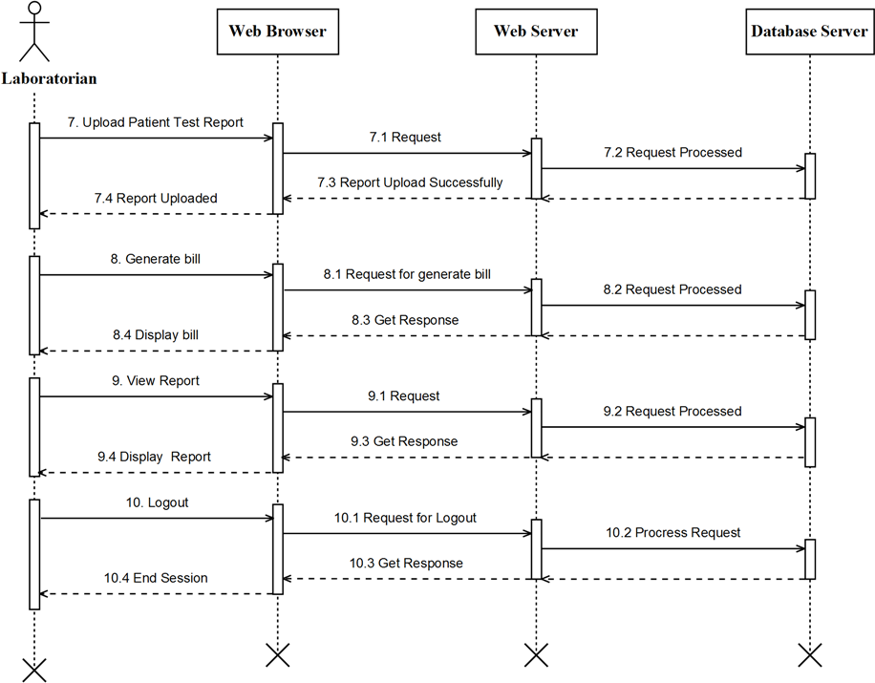

* + - 1. 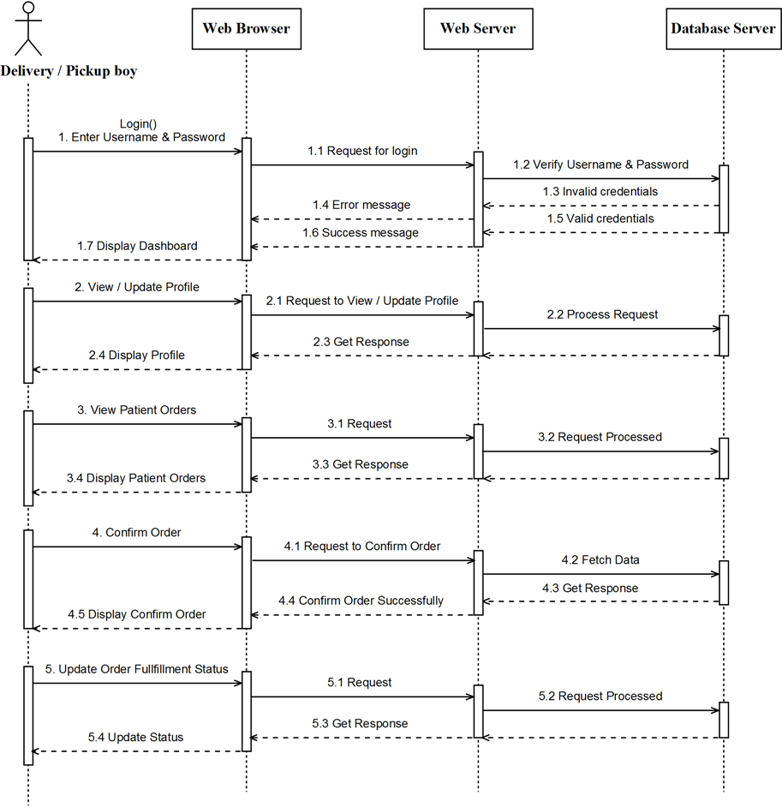Delivery / Pickup boy Sequence Diagram

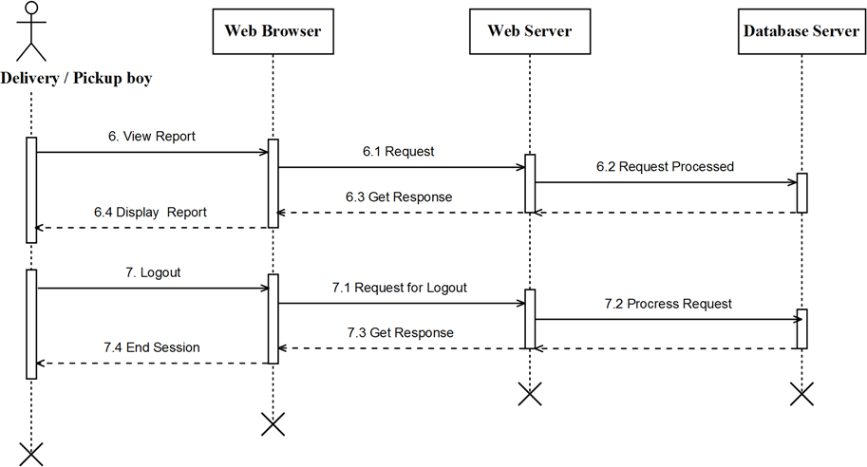

* + - 1. Manager Sequence Diagram

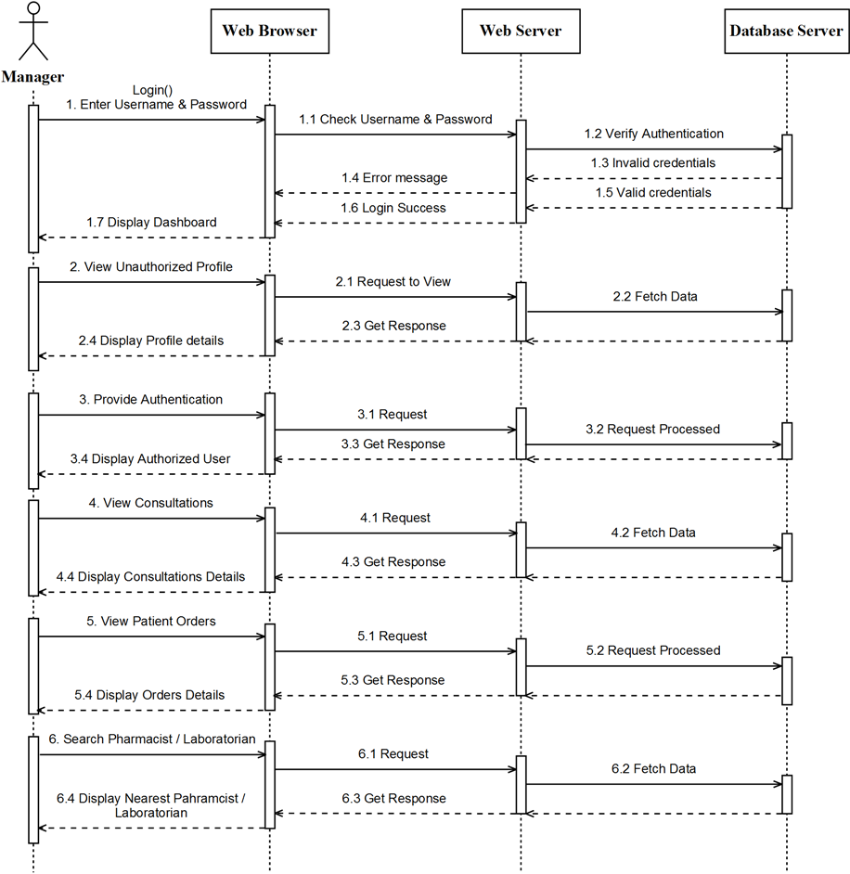

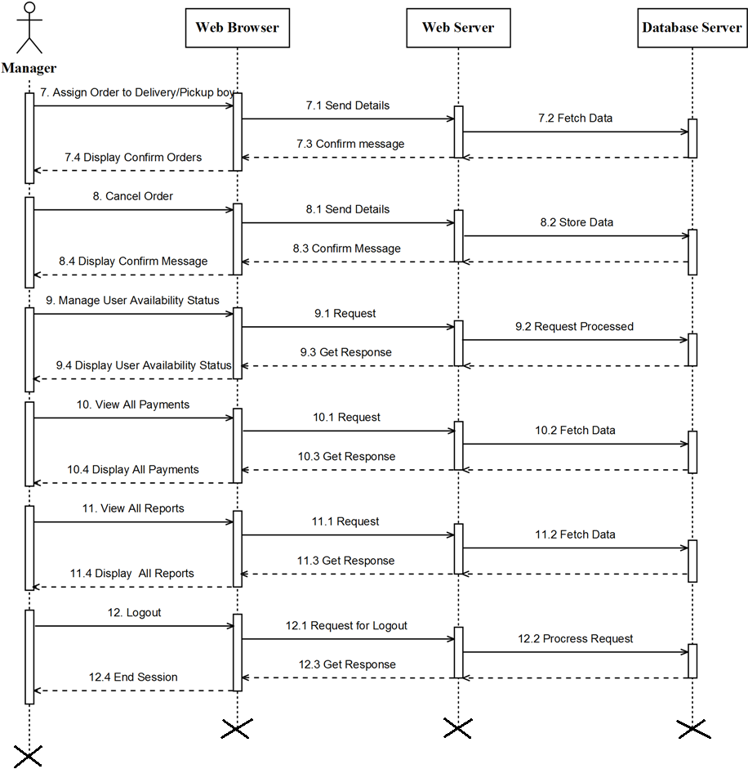

* + - 1. Admin Sequence Diagram

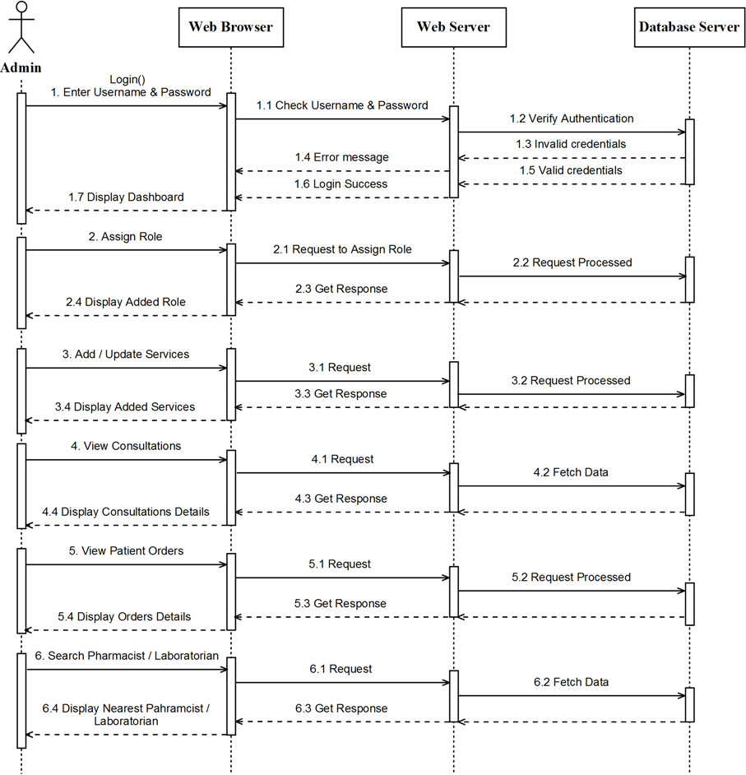

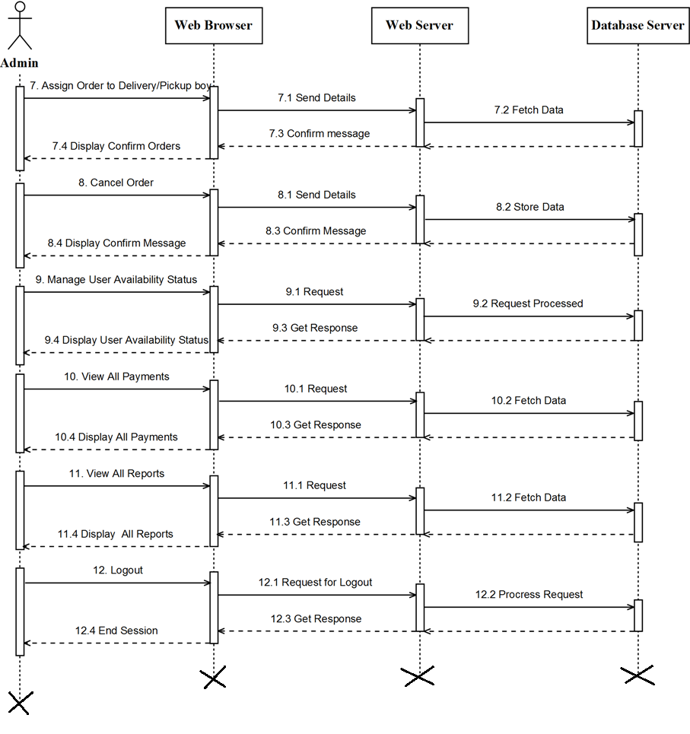

* **Activity Diagram :-**

1. Doctor Activity Diagram

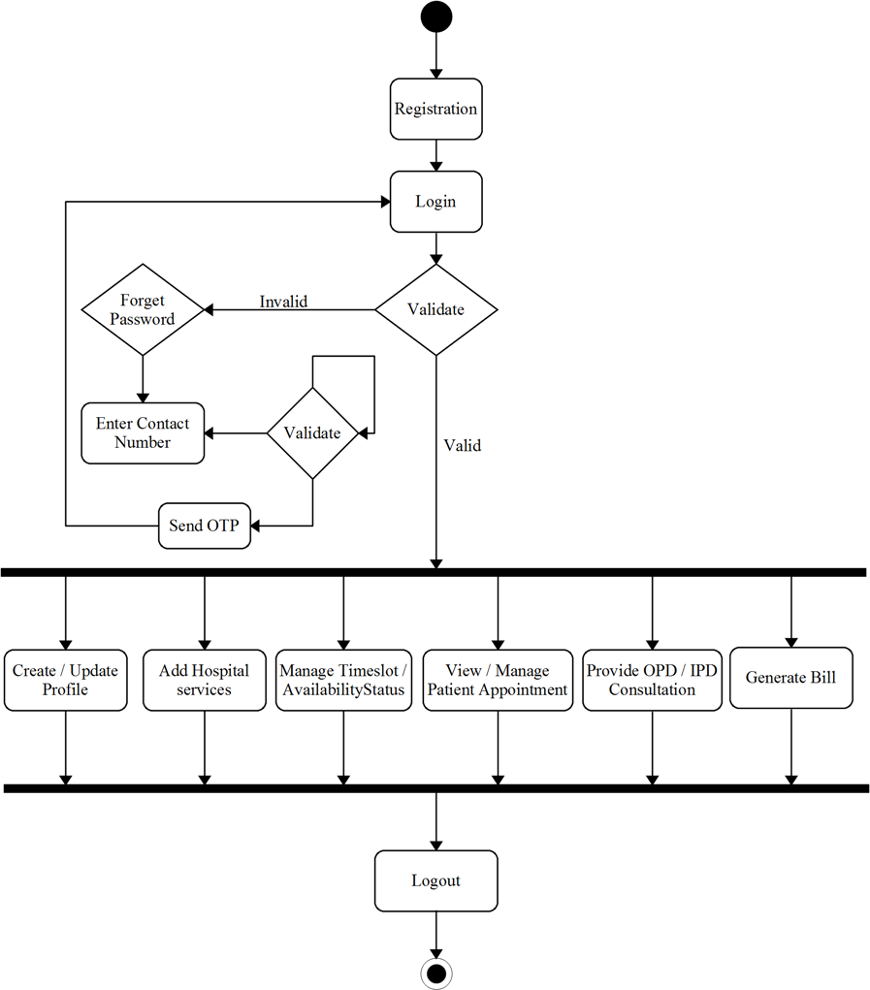

1. Pharmacist Activity Diagram

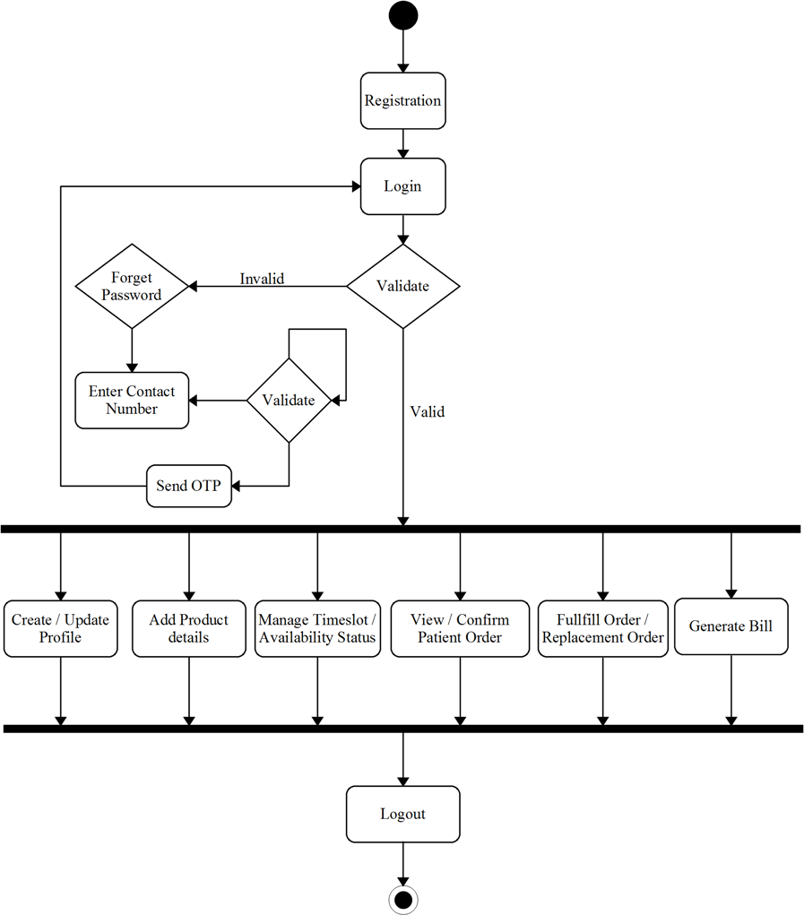

1. Laboratorian Activity Diagram

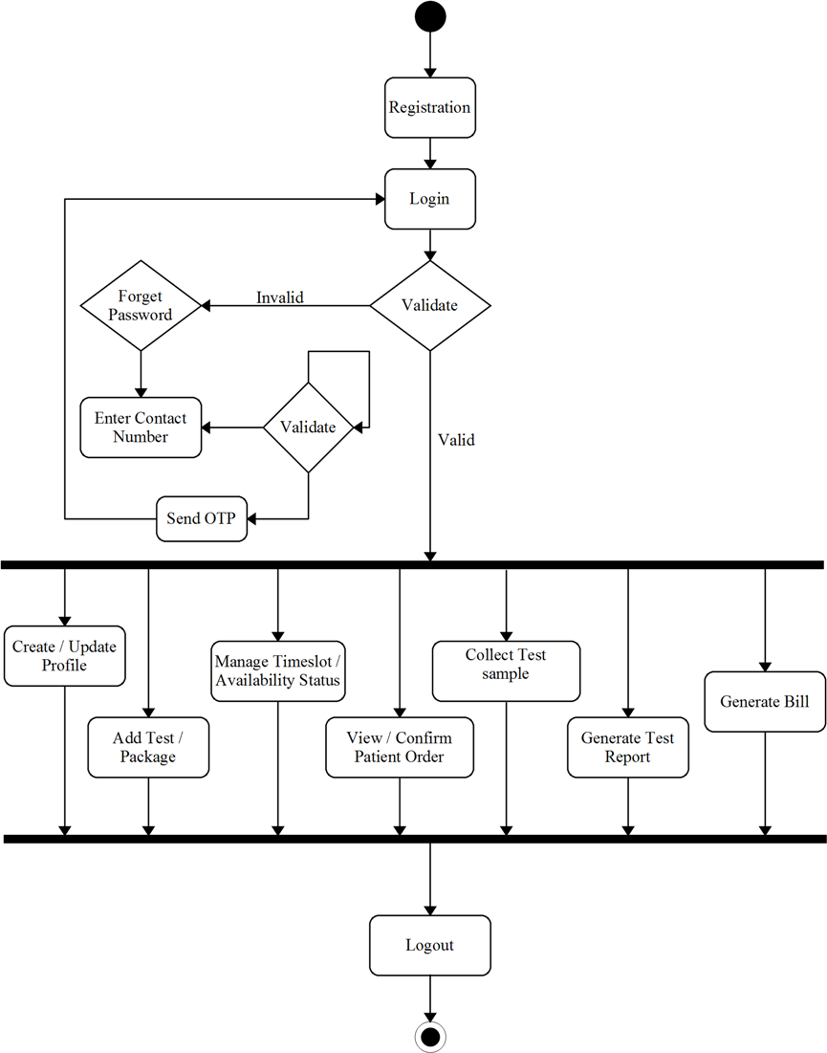

1. Delivery Boy Activity Diagram

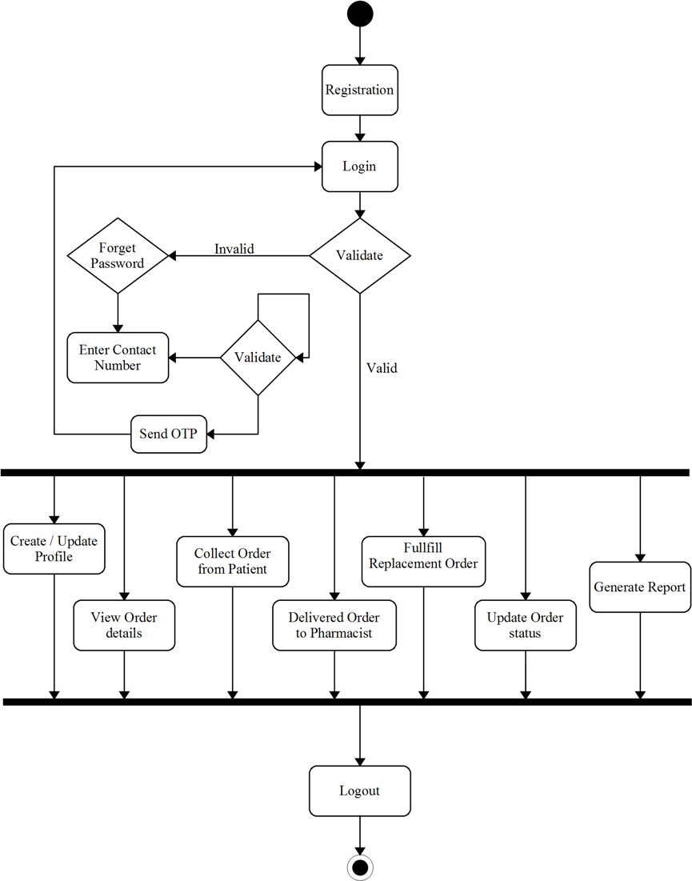

1. Pickup Boy Activity Diagram

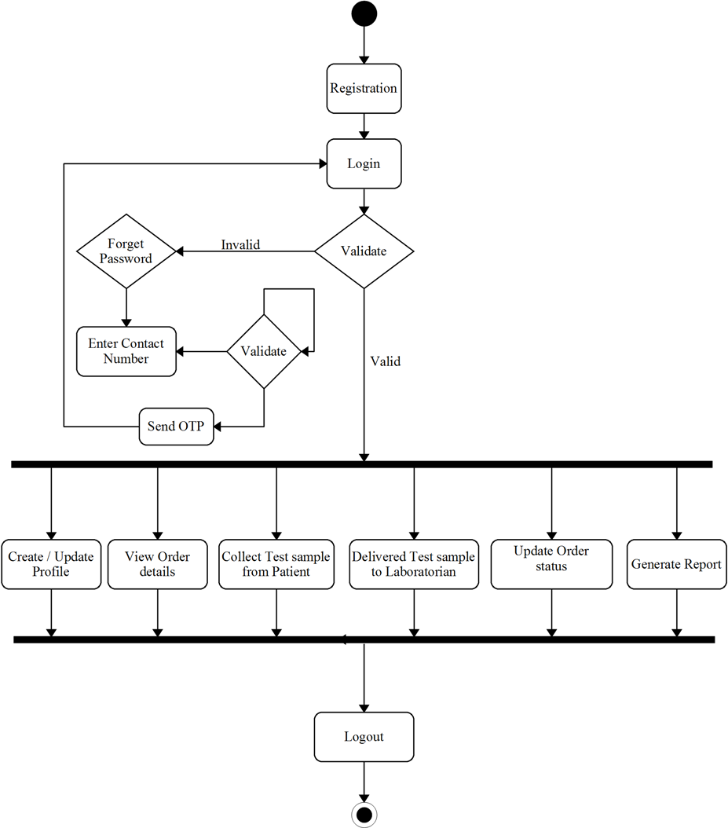

1. Manager Activity Diagram

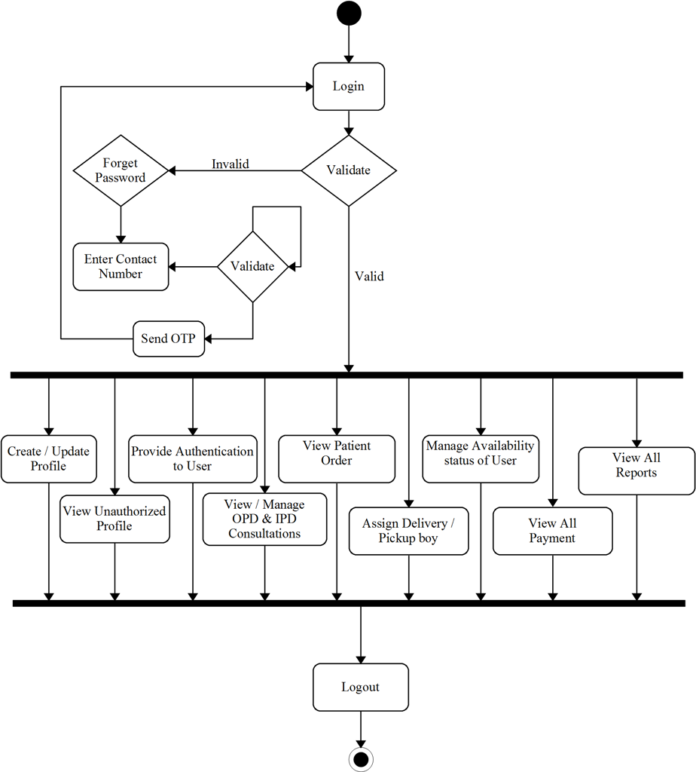

1. Admin Activity Diagram

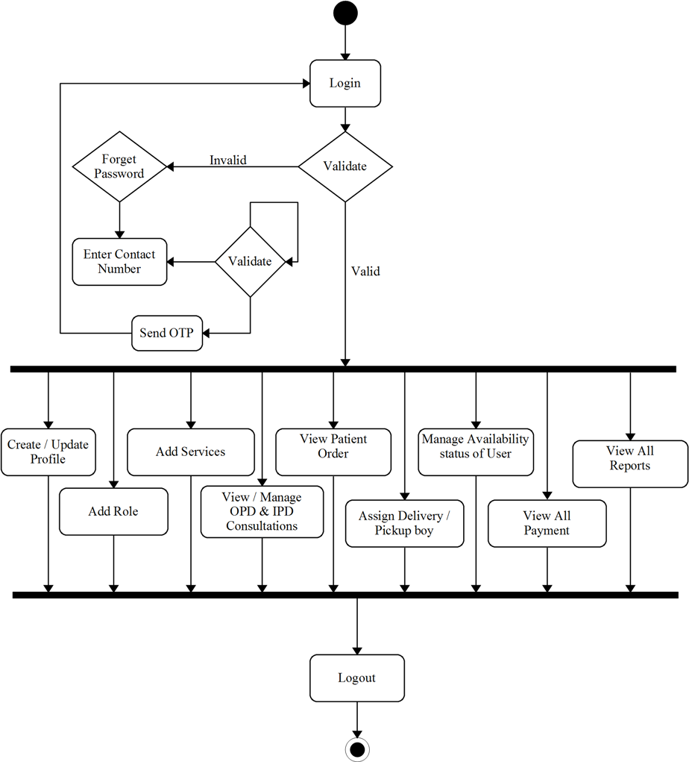

* 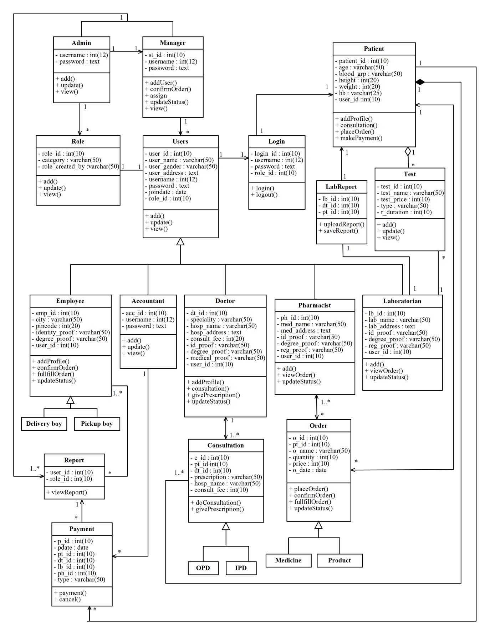**Class Diagram**
* 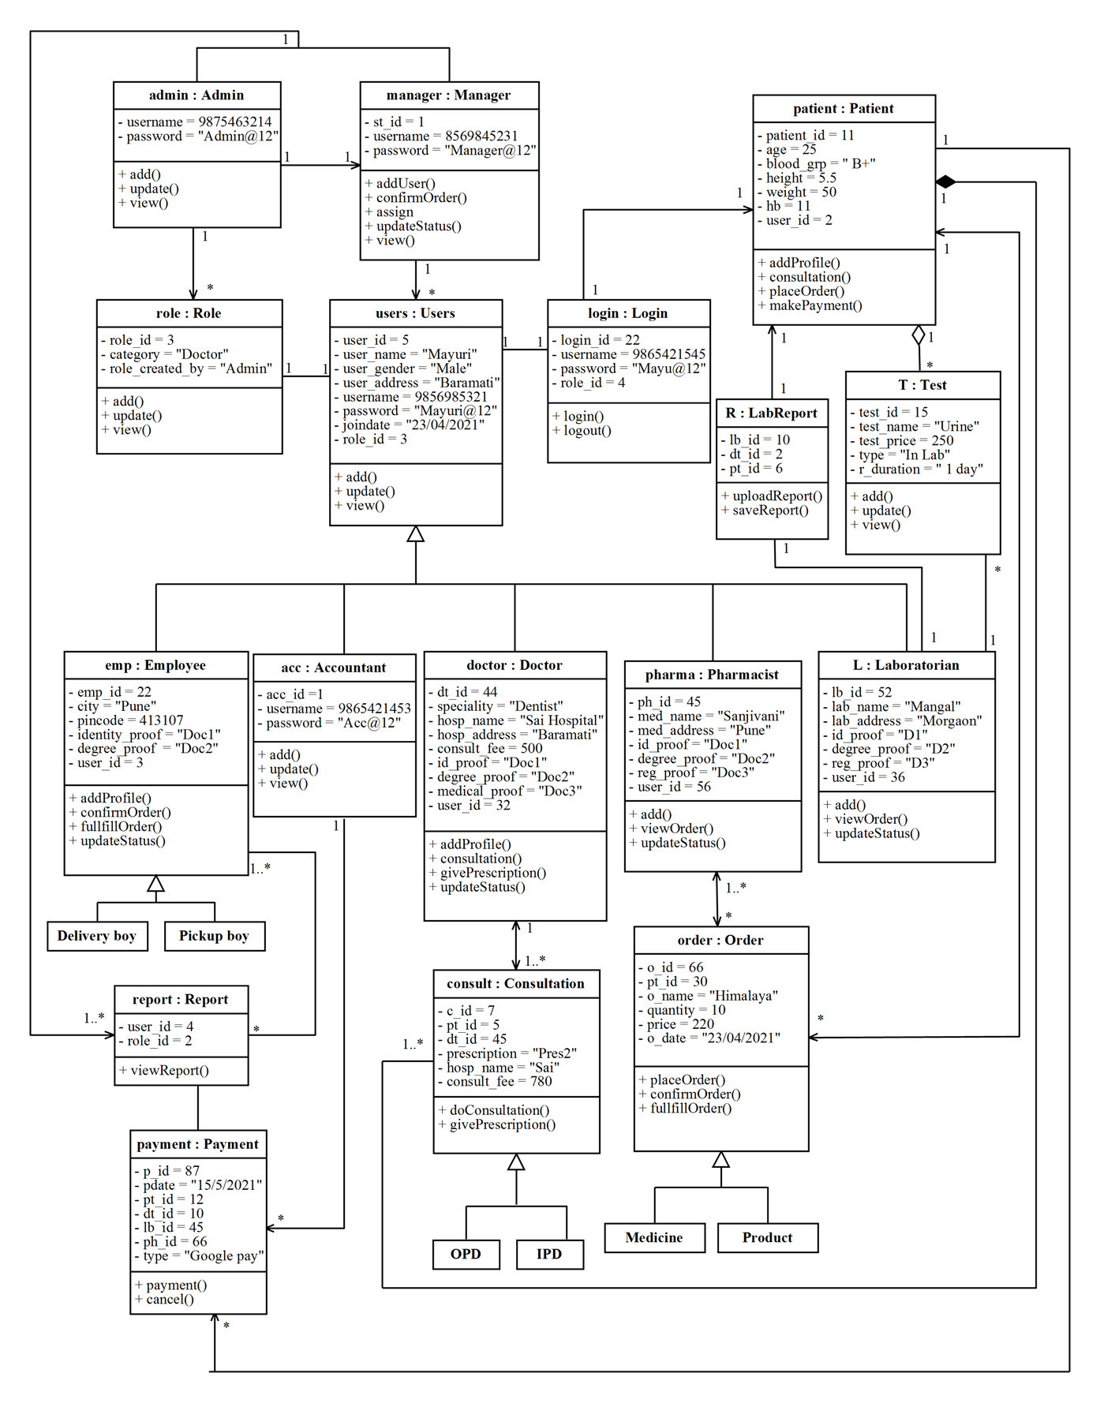**Object Diagram**
* **Component Diagram :-**

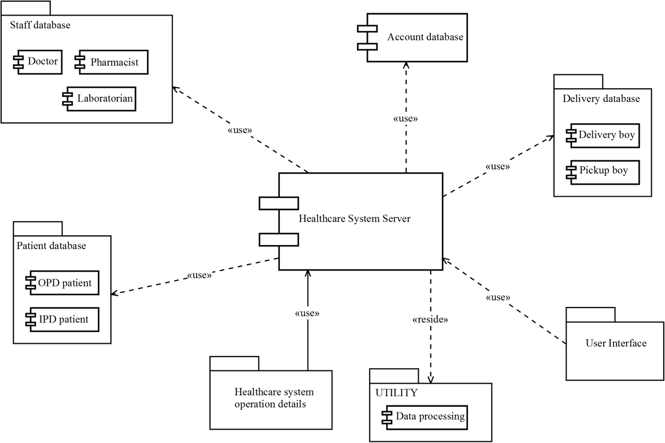

* **Deployment Diagram**

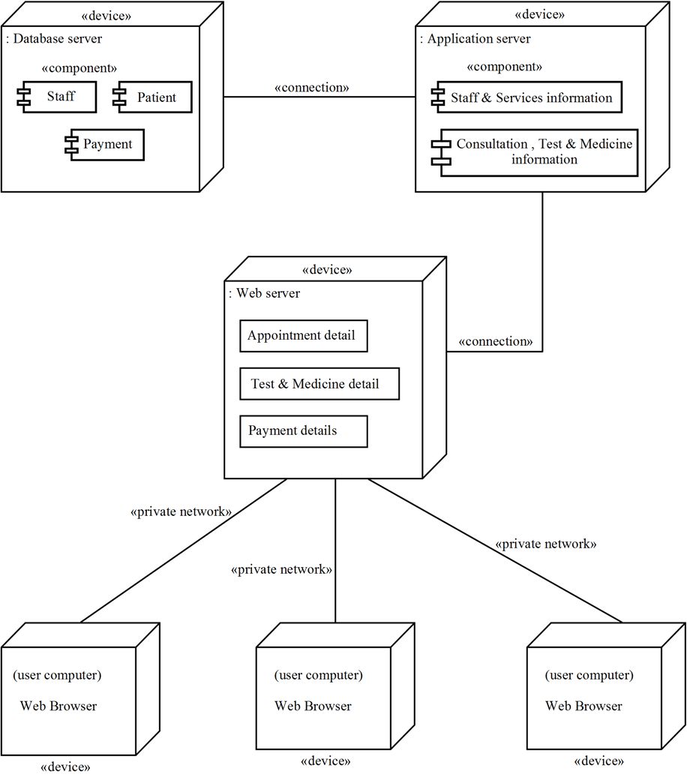

**User Interface Design :-**

Table Specification -

**1. Table Name: - tbl_registration**

|  |  |  |  |  |  |
| --- | --- | --- | --- | --- | --- |
| **Sr. No** | **Field Name** | **Data Type** | **Size** | **Constraints** | **Description** |
| 1 | user_id | int | 4 | Primary key | Unique key given to registration. |
| 2 | user_name | varchar | 25 | Not null | It specifies registration name. |
| 3 | user_gender | varchar | 15 | Not null | It specifies the user name. |
| 4 | user_dob | date | - | Not null | It specifies the user date of birth. |
| 5 | user_address | varchar | 25 | Not null | It specifies the user address. |
| 6 | user_pincode | varchar | 6 | Not null | It specifies the user area pincode. |
| 7 | user_email | varchar | 25 | Not null | It specifies the user email address. |
| 8 | username | int | 12 | Not null | It specifies the username(i.e. contact number of user). |
| 9 | otp | int | 6 | Not null | It specifies the user one time password. |
| 10 | password | varchar | 15 | Not null | It specifies the password of user. |
| 11 | booking_date | date | - | Not null | It specifies the user registration date. |
| 12 | role_id | int | 4 | Foreign key | Unique key given to role. |

**2. Table Name: -tbl_role**

|  |  |  |  |  |  |
| --- | --- | --- | --- | --- | --- |
| **Sr. No** | **Field Name** | **Data Type** | **Size** | **Constraints** | **Description** |
| 1 | role_id | int | 4 | Primary Key | Unique key given to role. |
| 2 | role_category | varchar | 15 | Not Null | It specifies the role category. |
| 3 | role_created_by | varchar | 15 | Not Null | It specifies the creator of role. |

**3. Table Name: -tbl_login**

|  |  |  |  |  |  |
| --- | --- | --- | --- | --- | --- |
| **Sr. No** | **Field Name** | **Data Type** | **Size** | **Constraints** | **Description** |
| 1 | login_id | int | 4 | Primary Key | Unique key given to login. |
| 2 | user_id | int | 4 | Not Null | Unique key given to registration. |
| 3 | status | int | 4 | Not Null | It specifies the status of user. |
| 4 | username | int | 12 | Not Null | It specifies the username (i.e. contact number of user). |
| 5 | password | varchar | 15 | Null | It specifies the password of user. |
| 6 | role_id | int | 4 | Not Null | Unique key given to role. |

**4. Table Name: -tbl_dtprofile**

|  |  |  |  |  |  |
| --- | --- | --- | --- | --- | --- |
| **Sr. No** | **Field Name** | **Data Type** | **Size** | **Constraints** | **Description** |
| 1 | dt_id | int | 4 | Primary key | Unique key given to doctor profile. |
| 2 | user_id | int | 4 | Foreign key | Unique key given to registration of user. |
| 3 | photo | varchar | 50 | Not null | It specifies the doctor photo. |
| 4 | degree | varchar | 25 | Not null | It specifies the degree of doctor. |
| 5 | speciality | varchar | 25 | Not null | It specifies the speciality of doctor. |
| 6 | college | varchar | 25 | Not null | It specifies the college name of doctor. |
| 7 | y_completion | int | 4 | Not null | It specifies the year of degree completion. |
| 8 | experience | varchar | 25 | Not null | It specifies the work experience |
| 9 | consult_fee | int | 10 | Not null | It specifies the consultation fee. |
| 10 | hospital_name | varchar | 25 | Not null | It specifies the hospital name. |
| 11 | hospital_landmark | varchar | 25 | Not null | It specifies the hospital address. |
| 12 | hospital_city | varchar | 25 | Not null | It specifies the city name of hospital. |
| 13 | hospital_state | varchar | 25 | Not null | It specifies the state name of hospital. |
| 14 | hospital_pincode | int | 6 | Not null | It specifies the pincode of hospital area. |
| 15 | hospital_contact | int | 12 | Not null | It specifies the contact number of hospital. |
| 16 | hospital_email | varchar | 25 | Not null | It specifies the email address of hospital. |
| 17 | identity_proof | varchar | 50 | Not null | It specifies the identity proof. |
| 18 | degree_proof | varchar | 50 | Not null | It specifies the degree proof. |
| 19 | medical_proof | varchar | 50 | Not null | It specifies the medical proof. |
| 20 | status | int | 4 | Not null | It specifies the status of authorized/unauthorized. |

**5. Table Name: - tbl_phprofile**

|  |  |  |  |  |  |
| --- | --- | --- | --- | --- | --- |
| **Sr. No** | **Field Name** | **Data Type** | **Size** | **Constraints** | **Description** |
| 1 | ph_id | int | 4 | Primary key | Unique key given to pharmacist profile. |
| 2 | user_id | int | 4 | Foreign key | Unique key given to registration of user. |
| 3 | photo | varchar | 50 | Not null | It specifies the pharmacist photo. |
| 4 | degree | varchar | 25 | Not null | It specifies the degree of pharmacist. |
| 5 | year | int | 4 | Not null | It specifies the year of degree completion. |
| 6 | medical_name | varchar | 25 | Not null | It specifies the medical name. |
| 7 | medical_contact | int | 12 | Not null | It specifies the medical contact number. |
| 8 | medical_landmark | varchar | 25 | Not null | It specifies the medical address. |
| 9 | medical_city | varchar | 25 | Not null | It specifies the city name of medical. |
| 10 | medical_state | varchar | 25 | Not null | It specifies the state name of medical. |
| 11 | medical_pincode | int | 6 | Not null | It specifies the area pincode of medical. |
| 12 | identity_proof | varchar | 50 | Not null | It specifies the identity proof. |
| 13 | degree_proof | varchar | 50 | Not null | It specifies the degree proof. |
| 14 | reg_proof | varchar | 50 | Not null | It specifies the medical proof. |
| 15 | status | int | 4 | Not null | It specifies the status of authorized/unauthorized. |

**6. Table Name: - tbl_lbprofile**

|  |  |  |  |  |  |
| --- | --- | --- | --- | --- | --- |
| **Sr. No** | **Field Name** | **Data Type** | **Size** | **Constraints** | **Description** |
| 1 | lb_id | int | 4 | Primary key | Unique key given to laboratorian profile. |
| 2 | user_id | int | 4 | Foreign key | Unique key given to registration of user. |
| 3 | photo | varchar | 50 | Not null | It specifies the laboratorian photo. |
| 4 | degree | varchar | 25 | Not null | It specifies the degree of laboratorian. |
| 5 | year | int | 4 | Not null | It specifies the year of degree completion. |
| 6 | lab_name | varchar | 25 | Not null | It specifies the lab name. |
| 7 | lab_contact | int | 12 | Not null | It specifies the lab contact number. |
| 8 | lab_landmark | varchar | 25 | Not null | It specifies the lab address. |
| 9 | lab_city | varchar | 25 | Not null | It specifies the city name of lab. |
| 10 | lab_state | varchar | 25 | Not null | It specifies the state name of lab. |
| 11 | lab_pincode | int | 6 | Not null | It specifies the area pincode of lab. |
| 12 | identity_proof | varchar | 50 | Not null | It specifies the identity proof. |
| 13 | degree_proof | varchar | 50 | Not null | It specifies the degree proof. |
| 14 | reg_proof | varchar | 50 | Not null | It specifies the medical proof. |
| 15 | status | int | 4 | Not null | It specifies the status of authorized/unauthorized. |

**7. Table Name: - tbl_ptprofile**

|  |  |  |  |  |  |
| --- | --- | --- | --- | --- | --- |
| **Sr. No** | **Field Name** | **Data Type** | **Size** | **Constraints** | **Description** |
| 1 | pt_id | int | 4 | Primary key | Unique key given to patient profile. |
| 2 | age | varchar | 4 | Not null | It specifies the age of patient. |
| 3 | blood_grp | varchar | 15 | Not null | It specifies the blood group. |
| 4 | height | float | - | Not null | It specifies the height. |
| 5 | weight | float | - | Not null | It specifies the weight. |
| 6 | hb | varchar | 25 | Not null | It specifies the hb. |
| 7 | user_id | int | 4 | Foreign key | Unique key given to user registration. |

**8. Table Name: - tbl_avldaytime**

|  |  |  |  |  |  |
| --- | --- | --- | --- | --- | --- |
| **Sr. No** | **Field Name** | **Data Type** | **Size** | **Constraints** | **Description** |
| 1 | adt_id | int | 4 | Primary key | Unique key given to availability of day and time. |
| 2 | user_id | int | 4 | Foreign key | Unique key given to user registration. |
| 3 | role_id | Int | 4 | Foreign key | Unique key given to user role. |
| 4 | avl_day | varchar | 25 | Not null | It specifies the available day of doctor/pharmacist/laboratorian. |
| 5 | avl_shift | varchar | 25 | Not null | It specifies the available shift of doctor/pharmacist/laboratorian. |
| 6 | avl_time | varchar | 25 | Not null | It specifies the available time of doctor/pharmacist/laboratorian. |
| 7 | booking_status | varchar | 25 | Not null | It specifies the status. |

**9. Table Name: - tbl_daprofile**

|  |  |  |  |  |  |
| --- | --- | --- | --- | --- | --- |
| **Sr. No** | **Field Name** | **Data Type** | **Size** | **Constraints** | **Description** |
| 1 | da_id | int | 4 | Primary key | Unique key given to delivery boy profile. |
| 2 | image | varchar | 50 | Not null | It specifies the photo. |
| 3 | qualification | varchar | 25 | Not null | It specifies the qualification. |
| 4 | yoc | int | 4 | Not null | It specifies the year of degree completion. |
| 5 | landmark | varchar | 25 | Not null | It specifies the address. |
| 6 | city | varchar | 25 | Not null | It specifies the city name. |
| 7 | state | varchar | 25 | Not null | It specifies the state name. |
| 8 | pincode | int | 6 | Not null | It specifies the area pincode of delivery boy. |
| 9 | identity_proof | varchar | 50 | Not null | It specifies the identity proof. |
| 10 | degree_proof | varchar | 50 | Not null | It specifies the degree proof. |
| 11 | reg_date | date | - | Not null | It specifies the registration date. |
| 12 | added_by | varchar | 25 | Not null | It specifies the name who is added delivery boy. |
| 13 | user_id | int | 4 | Foreign key | Unique key given to user registration. |

**10. Table Name: - tbl_dtward**

|  |  |  |  |  |  |
| --- | --- | --- | --- | --- | --- |
| **Sr. No** | **Field Name** | **Data Type** | **Size** | **Constraints** | **Description** |
| 1 | ward_id | int | 4 | Primary key | Unique key given to ward. |
| 2 | ward_cat | varchar | 25 | Not null | It specifies the ward category. |
| 5 | dt_id | int | 4 | Foreign key | Unique key given to doctor profile. |

**11. Table Name: - tbl_dtbed**

|  |  |  |  |  |  |
| --- | --- | --- | --- | --- | --- |
| **Sr. No** | **Field Name** | **Data Type** | **Size** | **Constraints** | **Description** |
| 1 | bed_id | int | 4 | Primary key | Unique key given to bed. |
| 2 | total_bed | int | 4 | Not null | It specifies the total bed. |
| 3 | price | int | 4 | Not null | It specifies the price per bed. |
| 4 | ward_id | int | 4 | Foreign key | Unique key given to ward. |
| 5 | dt_id | int | 4 | Foreign key | Unique key given to doctor profile. |

**12. Table Name: - tbl_dthospitalservices**

|  |  |  |  |  |  |
| --- | --- | --- | --- | --- | --- |
| **Sr. No** | **Field Name** | **Data Type** | **Size** | **Constraints** | **Description** |
| 1 | hs_id | int | 4 | Primary key | Unique key given to hospital services. |
| 2 | Other_service_name | varchar | 25 | Not null | It specifies the service name. |
| 3 | charges | int | 4 | Not null | It specifies the service charge. |
| 4 | dt_id | int | 4 | Foreign key | Unique key given to doctor profile. |

**13. Table Name: - tbl_leave**

|  |  |  |  |  |  |
| --- | --- | --- | --- | --- | --- |
| **Sr. No** | **Field Name** | **Data Type** | **Size** | **Constraints** | **Description** |
| 1 | leave_id | int | 4 | Primary key | Unique key given to leave. |
| 2 | date_from | date | - | Not null | It specifies the leave start date. |
| 3 | date_to | date | - | Not null | It specifies the leave end date. |
| 4 | reason | varchar | 25 | Not null | It specifies the reason of leave. |
| 5 | user_id | int | 4 | Foreign key | Unique key given to user registration. |

**14. Table Name: - tbl_hcprofile**

|  |  |  |  |  |  |
| --- | --- | --- | --- | --- | --- |
| **Sr. No** | **Field Name** | **Data Type** | **Size** | **Constraints** | **Description** |
| 1 | hc_id | int | 4 | Primary key | Unique key given to pick up boy profile. |
| 2 | image | varchar | 50 | Not null | It specifies the photo. |
| 3 | qualification | varchar | 25 | Not null | It specifies the qualification. |
| 4 | yoc | int | 4 | Not null | It specifies the year of degree completion. |
| 5 | landmark | varchar | 25 | Not null | It specifies the address. |
| 6 | city | varchar | 25 | Not null | It specifies the city name. |
| 7 | state | varchar | 25 | Not null | It specifies the state name. |
| 8 | pincode | int | 6 | Not null | It specifies the area pincode of pickup boy. |
| 9 | identity_proof | varchar | 50 | Not null | It specifies the identity proof. |
| 10 | degree_proof | varchar | 50 | Not null | It specifies the degree proof. |
| 11 | reg_date | date | - | Not null | It specifies the registration date. |
| 12 | added_by | varchar | 25 | Not null | It specifies the name who is added pickup boy. |
| 13 | user_id | int | 4 | Foreign key | Unique key given to user registration. |

**15. Table Name: - tbl_lbpackage**

|  |  |  |  |  |  |
| --- | --- | --- | --- | --- | --- |
| **Sr. No** | **Field Name** | **Data Type** | **Size** | **Constraints** | **Description** |
| 1 | package_id | int | 4 | Primary key | Unique key given to package. |
| 2 | lb_id | int | 4 | Foreign key | Unique key given to laboratorian profile. |
| 3 | package_added_date | date | - | Not null | It specifies the package added date. |
| 4 | package_name | varchar | 25 | Not null | It specifies the package name. |
| 5 | package_expire_date | date | - | Not null | It specifies the package expiring date. |
| 6 | package_price | int | 4 | Not null | It specifies the package price. |
| 7 | package_duration | int | 4 | Not null | It specifies the package duration. |

**16. Table Name: - tbl_lbpackages_test**

|  |  |  |  |  |  |
| --- | --- | --- | --- | --- | --- |
| **Sr. No** | **Field Name** | **Data Type** | **Size** | **Constraints** | **Description** |
| 1 | test_package_id | int | 4 | Primary key | Unique key given to test into package. |
| 2 | test_name | varchar | 25 | Not null | It specifies the test names into package. |
| 3 | package_id | int | 4 | Foreign key | Unique key given to package. |
| 4 | lb_id | int | 4 | Foreign key | Unique key given to laboratorian profile. |

**17. Table Name: - tbl_lbtest**

|  |  |  |  |  |  |
| --- | --- | --- | --- | --- | --- |
| **Sr. No** | **Field Name** | **Data Type** | **Size** | **Constraints** | **Description** |
| 1 | test_id | int | 4 | Primary key | Unique key given to test. |
| 2 | user_id | int | 4 | Foreign key | Unique key given to user registration. |
| 3 | lb_id | int | 4 | Foreign key | Unique key given to laboratorian profile. |
| 4 | test_added_date | date | - | Not null | It specifies the test added date. |
| 5 | test_name | varchar | 25 | Not null | It specifies the test name. |
| 6 | test_price | int | 4 | Not null | It specifies the test price. |
| 7 | test_report_duration | int | 4 | Not null | It specifies the report duration of test. |
| 8 | test_type | varchar | 25 | Not null | It specifies the test type(i.e. In lab/Home collection) |
| 9 | collecting_sample | varchar | 25 | Not null | It specifies the which sample is collect. |

**18. Table Name: - tbl_phproduct_brand**

|  |  |  |  |  |  |
| --- | --- | --- | --- | --- | --- |
| **Sr. No** | **Field Name** | **Data Type** | **Size** | **Constraints** | **Description** |
| 1 | brand_id | int | 4 | Primary key | Unique key given to brand. |
| 2 | brand_name | varchar | 25 | Not null | It specifies the brand name. |
| 5 | add_date | date | - | Not null | It specifies the product brand added date. |
| 7 | ph_id | int | 4 | Foreign key | Unique key given to pharmacist profile. |

**19. Table Name: - tbl_phproduct_category**

|  |  |  |  |  |  |
| --- | --- | --- | --- | --- | --- |
| **Sr. No** | **Field Name** | **Data Type** | **Size** | **Constraints** | **Description** |
| 1 | category_id | int | 4 | Primary key | Unique key given to category. |
| 2 | category_name | varchar | 25 | Not null | It specifies the category name. |
| 5 | add_date | date | - | Not null | It specifies the product category added date. |
| 7 | ph_id | int | 4 | Foreign key | Unique key given to pharmacist profile. |

**20. Table Name: - tbl_phproduct**

|  |  |  |  |  |  |
| --- | --- | --- | --- | --- | --- |
| **Sr. No** | **Field Name** | **Data Type** | **Size** | **Constraints** | **Description** |
| 1 | product_id | int | 4 | Primary key | Unique key given to product. |
| 2 | product_name | varchar | 25 | Not null | It specifies the product name. |
| 3 | product_quantity | int | 4 | Foreign key | It specifies the product quantity. |
| 4 | product_price | int | 4 | Not null | It specifies the product price. |
| 5 | add_date | date | - | Not null | It specifies the product added date. |
| 6 | product_expyear | int | 4 | Not null | It specifies the product expiring year. |
| 7 | ph_id | int | 4 | Foreign key | Unique key given to pharmacist profile. |
| 8 | category_id | int | 4 | Foreign key | Unique key given to category. |
| 9 | brand_id | int | 4 | Foreign key | Unique key given to brand. |

**21. Table Name: - tbl_ptdisease**

|  |  |  |  |  |  |
| --- | --- | --- | --- | --- | --- |
| **Sr. No** | **Field Name** | **Data Type** | **Size** | **Constraints** | **Description** |
| 1 | disease_id | int | 4 | Primary key | Unique key given to disease. |
| 2 | symptom | varchar | 25 | Not null | It specifies the symptoms. |
| 3 | finding_symptom | varchar | 25 | Not null | It specifies the patient symptoms. |
| 4 | family_histry_disease | varchar | 25 | Not null | It specifies the patient family disease history. |
| 5 | personal_histry_disease | date | - | Not null | It specifies the personal disease history. |
| 6 | patient_type | int | 4 | Not null | It specifies the patient type (i.e. IPD/OPD). |
| 7 | pt_id | int | 4 | Foreign key | Unique key given to patient profile. |
| 8 | dt_id | int | 4 | Foreign key | Unique key given to doctor profile. |

**22. Table Name: - tbl_ptfamily**

|  |  |  |  |  |  |
| --- | --- | --- | --- | --- | --- |
| **Sr. No** | **Field Name** | **Data Type** | **Size** | **Constraints** | **Description** |
| 1 | family_member_id | int | 4 | Primary key | Unique key given to family member. |
| 2 | name | varchar | 25 | Not null | It specifies the name of family member. |
| 3 | blood_grp | varchar | 25 | Not null | It specifies the blood group. |
| 4 | weight | float | - | Not null | It specifies the weight. |
| 5 | height | float | - | Not null | It specifies the height |
| 6 | hb | int | 4 | Not null | It specifies the hb. |
| 7 | relation | varchar | 25 | Not null | It specifies the family member relation with patient. |
| 8 | family_histry_disease | varchar | 25 | Not null | It specifies the family disease history. |
| 9 | personal_histry_disease | varchar | 25 | Not null | It specifies the personal disease history. |
| 10 | address | varchar | 25 | Not null | It specifies the address. |
| 11 | dob | date | - | Not null | It specifies the date of birth. |
| 12 | mob_no | int | 12 | Not null | It specifies the contact number. |
| 13 | pt_id | int | 4 | Foreign key | Unique key given to patient profile. |
| 14 | added_date | date | - | Not null | It specifies the family member added date. |

**23. Table Name: - tbl_pthealthlocker**

|  |  |  |  |  |  |
| --- | --- | --- | --- | --- | --- |
| **Sr. No** | **Field Name** | **Data Type** | **Size** | **Constraints** | **Description** |
| 1 | healthlocker_id | int | 4 | Primary key | Unique key given to healthlocker. |
| 2 | photo | varchar | 25 | Not null | It specifies the image of upload document. |
| 3 | record_title | varchar | 25 | Not null | It specifies the document title. |
| 4 | record_type | varchar | - | Not null | It specifies the document type (i.e. prescription or other document). |
| 5 | record_by | varchar | - | Not null | It specifies the self or family member document. |
| 6 | pt_id | int | 4 | Foreign key | Unique key given to patient profile. |
| 7 | family_member_id | int | 25 | Foreign key | Unique key given to family member. |

**24. Table Name: - tbl_ptinclinic_consultation**

|  |  |  |  |  |  |
| --- | --- | --- | --- | --- | --- |
| **Sr. No** | **Field Name** | **Data Type** | **Size** | **Constraints** | **Description** |
| 1 | inclinic_consult_id | int | 4 | Primary key | Unique key given to in clinic consultation. |
| 2 | booking_date | date | - | Not null | It specifies the booking date. |
| 3 | oppointment_date | date | - | Not null | It specifies the in clinic appointment date. |
| 4 | symptoms | varchar | 25 | Not null | It specifies the symptoms of patient. |
| 5 | dt_id | int | 4 | Foreign key | Unique key given to doctor profile. |
| 6 | family_member_id | int | 4 | Foreign key | Unique key given to family member. |
| 7 | pt_id | int | 4 | Foreign key | Unique key given to patient profile. |
| 8 | adt_id | int | 4 | Foreign key | Unique key given to available day and time. |
| 9 | status | varchar | 25 | Not null | It specifies the status (Pending/Complete). |

**25. Table Name: - tbl_ptlabtest_booking**

|  |  |  |  |  |  |
| --- | --- | --- | --- | --- | --- |
| **Sr. No** | **Field Name** | **Data Type** | **Size** | **Constraints** | **Description** |
| 1 | testbooking_id | int | 4 | Primary key | Unique key given to test booking. |
| 2 | pt_id | int | 4 | Foreign key | Unique key given to patient profile. |
| 3 | lb_id | int | 4 | Foreign key | Unique key given to laboratorian profile. |
| 4 | booking_date | date | - | Not null | It specifies the booking date of test. |
| 5 | family_member_id | int | 4 | Foreign key | Unique key given to family member. |
| 6 | adt_id | int | 4 | Foreign key | Unique key given to available day and time. |
| 7 | test_id | int | 4 | Foreign key | Unique key given to test. |
| 8 | status | varchar | 25 | varchar | It specifies the status (Pending/Complete). |
| 9 | pickup_date | date | - | Not null | It specifies the pickup date. |
| 10 | pickup_time | varchar | 25 | Not null | It specifies the pickup time. |

**26. Table Name: - tbl_ptmycart**

|  |  |  |  |  |  |
| --- | --- | --- | --- | --- | --- |
| **Sr. No** | **Field Name** | **Data Type** | **Size** | **Constraints** | **Description** |
| 1 | cart_product_id | int | 4 | Primary key | Unique key given to cart. |
| 2 | order_date | date | - | Not null | It specifies the product order date. |
| 3 | product_quantity | int | 4 | Not null | It specifies the order product quantity. |
| 4 | total_price | float | - | Not null | It specifies the total price of product. |
| 5 | status | varchar | 4 | Not null | It specifies the status (Pending/Complete). |
| 6 | product_id | int | 4 | Foreign key | Unique key given to product. |
| 7 | pt_id | int | 4 | Foreign key | Unique key given to patient profile. |
| 8 | ph_id | int | 4 | Foreign key | Unique key given to pharmacist profile. |

**27. Table Name: - tbl_ptonline_consultation**

|  |  |  |  |  |  |
| --- | --- | --- | --- | --- | --- |
| **Sr. No** | **Field Name** | **Data Type** | **Size** | **Constraints** | **Description** |
| 1 | consult_id | int | 4 | Primary key | Unique key given to online consultation. |
| 2 | booking_date | date | - | Not null | It specifies the booking date. |
| 3 | consult_date | date | - | Not null | It specifies the consultation date. |
| 4 | symptoms | varchar | 25 | Not null | It specifies the symptoms of patient. |
| 5 | dt_id | int | 4 | Foreign key | Unique key given to doctor profile. |
| 6 | pt_id | int | 4 | Foreign key | Unique key given to patient profile. |
| 7 | family_member_id | int | 4 | Foreign key | Unique key given to family member. |
| 8 | adt_id | int | 4 | Foreign key | Unique key given to available day and time. |
| 9 | status | varchar | 25 | Not null | It specifies the status (Pending/Complete). |

**28. Table Name: - tbl_ptopd**

|  |  |  |  |  |  |
| --- | --- | --- | --- | --- | --- |
| **Sr. No** | **Field Name** | **Data Type** | **Size** | **Constraints** | **Description** |
| 1 | opd_id | int | 4 | Primary key | Unique key given to opd. |
| 2 | allocate_ward | varchar | 25 | Not null | It specifies the allocate ward (i.e. AC/Non-AC). |
| 3 | allocate_bed | int | 4 | Not null | It specifies the allocate bed to the patient. |
| 4 | dt_id | int | 4 | Foreign key | Unique key given to doctor profile. |
| 5 | pt_id | int | 4 | Foreign key | Unique key given to patient profile. |
| 6 | admit_date | date | - | Not null | It specifies the admit date of patient. |

**29. Table Name: - tbl_ptorder_product**

|  |  |  |  |  |  |
| --- | --- | --- | --- | --- | --- |
| **Sr. No** | **Field Name** | **Data Type** | **Size** | **Constraints** | **Description** |
| 1 | product_prder_id | int | 4 | Primary key | Unique key given order product. |
| 2 | product_quantity | int | 4 | Not null | It specifies the product quantity. |
| 3 | total_price | int | 4 | Not null | It specifies the total price of product. |
| 4 | order_date | date | - | Not null | It specifies the order date of product. |
| 5 | pt_id | int | 4 | Foreign key | Unique key given to patient profile. |
| 6 | ph_id | int | 4 | Foreign key | Unique key given to pharmacist profile. |
| 7 | product_id | int | 4 | Foreign key | Unique key given to product. |
| 8 | status | varchar | 25 | Not null | It specifies the status (Pending/Complete). |

**30. Table Name: - tbl_ptprescription**

|  |  |  |  |  |  |
| --- | --- | --- | --- | --- | --- |
| **Sr. No** | **Field Name** | **Data Type** | **Size** | **Constraints** | **Description** |
| 1 | prescription_id | int | 4 | Primary key | Unique key given to prescription. |
| 2 | mediciene | varchar | 25 | Not null | It specifies the medicine name. |
| 3 | dossage | int | 4 | Not null | It specifies the dosage of medicine. |
| 4 | notes | varchar | 25 | Not null | It specifies the extra note. |
| 5 | next_visit | date | - | Not null | It specifies the next visit date. |
| 6 | advice | varchar | 25 | Not null | It specifies the advice. |
| 7 | pdate | date | - | Not null | It specifies the prescription date. |
| 8 | dt_id | int | 4 | Foreign key | Unique key given to doctor profile. |
| 9 | pt_id | int | 4 | Foreign key | Unique key given to patient profile. |

**31. Table Name: - tbl_pttest_reports**

|  |  |  |  |  |  |
| --- | --- | --- | --- | --- | --- |
| **Sr. No** | **Field Name** | **Data Type** | **Size** | **Constraints** | **Description** |
| 1 | report_id | int | 4 | Primary key | Unique key given to test report. |
| 2 | pt_id | int | 4 | Foreign key | Unique key given to patient profile. |
| 3 | lb_id | int | 4 | Foreign key | Unique key given to laboratorian profile. |
| 4 | test_id | int | 4 | Foreign key | Unique key given to test. |
| 5 | report | varchar | 25 | Not null | It specifies the report of test. |

**32. Table Name: - tbl_stassign_da**

|  |  |  |  |  |  |
| --- | --- | --- | --- | --- | --- |
| **Sr. No** | **Field Name** | **Data Type** | **Size** | **Constraints** | **Description** |
| 1 | assign_da_id | int | 4 | Primary key | Unique key given to assign delivery boy. |
| 2 | da_id | int | 4 | Foreign key | Unique key given to delivery boy profile. |
| 3 | product_order_id | int | 4 | Foreign key | Unique key given to product order. |
| 4 | assign_order_date | date | - | Not null | It specifies the order assign date. |
| 5 | pickup_date | date | - | Not null | It specifies the order pickup date. |
| 6 | pickup_time | varchar | 25 | Not null | It specifies the order pickup time. |
| 7 | pickup_status | varchar | 25 | Not null | It specifies the order pickup status. |

**33. Table Name: - tbl_stassign_hc**

|  |  |  |  |  |  |
| --- | --- | --- | --- | --- | --- |
| **Sr. No** | **Field Name** | **Data Type** | **Size** | **Constraints** | **Description** |
| 1 | assign_hc_id | int | 4 | Primary key | Unique key given to assign pickup boy. |
| 2 | hc_id | int | 4 | Foreign key | Unique key given to pick up boy profile. |
| 3 | testbooking_id | int | 4 | Foreign key | Unique key given to booking test. |
| 4 | assign_order_date | date | - | Not null | It specifies the test assign date. |
| 7 | pickup_status | varchar | 25 | Not null | It specifies the test pickup status. |

**Test Procedures and Implementation**

• Test Case for Login

|  |  |  |  |  |  |
| --- | --- | --- | --- | --- | --- |
| **Login window case.** | | | | | |
| **Test No** | **Test description** | **Prerequisite condition** | **Expected Result** | **Actual Result** | **Remark** |
| Test 1 | To check the authenticated login window having 2 textboxes with one button | The login window is properly designed | The window login window is properly designed | The login window having the one title login and button Named login. | PASS |
| Test 2 | For login, valid username and password is to be Entered. | Valid username and password | Successful login | Successful Login | PASS |
| Test 3 | For login, valid username and password is to be Entered. | Invalid username and password | Successful Login | Login failed | FAIL |

• Test Case for Registration form

|  |  |  |  |  |  |
| --- | --- | --- | --- | --- | --- |
| **Test No** | **Test description** | **Prerequisite condition** | **Expected Result** | **Actual Result** | **Remark** |
| Test 1 | The registration form to check the appropriate labels and textboxes | The registration form having the appropriate labels and textboxes | The form will be the appropriate format | The registration form is correct format. | PASS |
| Test 2 | To check the user enter the name in the textbox in front of Name. |  | Entering the name in the text box the form will be accept it. Or not accepting the number or character or number or special Symbols. | The user entering name in the textbox then the accept the character only | PASS |
| Test 3 | The entering mobile no in the mobile no text box |  | Entering mobile no in the text box in the range of mobile no validation and Accept 10 digit. | The user entering the mobile no out of range the error message not display. | FAIL |

**Chapter 5**

**User Manual**

**User Manual :-**

This manual will be order to get overall idea about the system this is to be used. This manual will explain the need scope of a user manual as well as outline the suggested organization and content of user manual.

**Purpose -**

A user manual is prepared just before the implementation phase in the system development life cycle. The objective of the user manual is too clearly described and documents the operating of the system for the user department, in specific, Non-ambiguous and non-technical terms.

The ultimate test for any system is whether it can be used efficiently and effectively. A system cannot implement itself. It needs to people to start, use and maintain it, but they must learn how. Providing documentation that teaches how is the part of responsibility of every individual, as member of the system development team. The need for user manual arises for the following reasons.

• The user manual represents the entry point into the system from the end user angle

• The manual provides a chronological and view all the information necessary to understand and use the system within the user environment. It thus server as a hand book that instruct user how to access the system, run program , correct mistakes and solve the problem.

• The manual identifies the task which must be carried out by the user, in using the system, the objectives of those takes and the main deliverables which signify successful completion of each task.

• In many cases the manual is the sole means of learning how to the work or how to correct errors.

• A comprehensive user manual describes in details all system inputs, processor, outputs and control and provides background reading to supplement training and testing.

**Operations Manual/Menu Explanations :-**

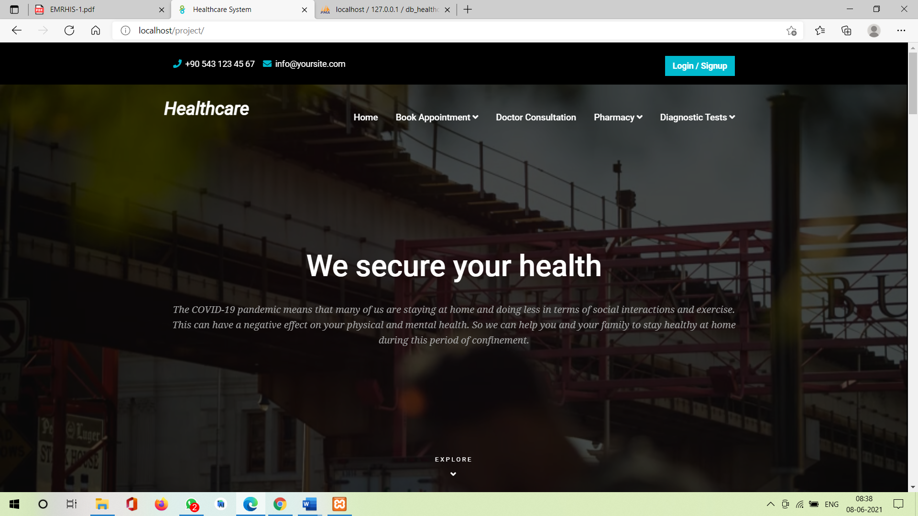

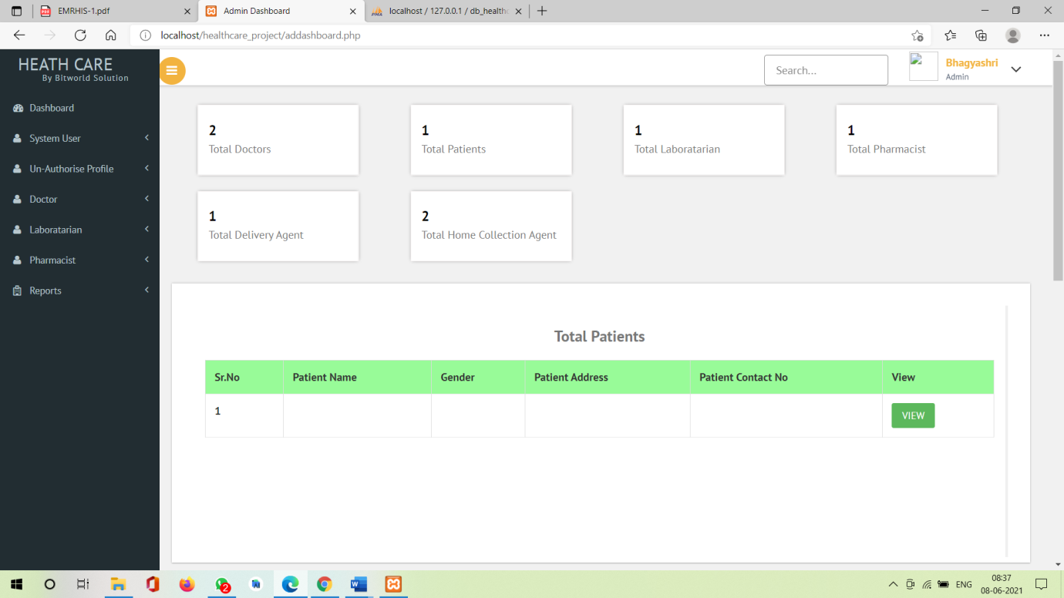

**Chapter 6**

**Benefits, Limitations**

**&**

**Conclusion**

**Benefits of the system :-**

#### **Consulting Doctors -**

To search the doctors based on their specialization, hospital name and location.

#### **Doorstep Medicine Delivery -**

Patient can order products/medicine of their choice from the convenience of their house.

* **Test Sample -**

All lab tests can be done at your home or office. The final reports will be upload to you.

#### **The Smart Way to Health -**

Verified information and trustworthy tips, to guide you to better health every day.

#### **Health Locker -**

Stored all your medical records online. Keep all your medical documents safe & easily access them.

* **Appointment Management -**

Only after the doctor confirms or accepts the request, the patient should get notified about the book appointment.

**Limitations of the system :-**

* Dedicating Time to Health Care System Training.

**Conclusion of the system :-**

The “**Healthcare System**” made everything more easy and comfortable plus the entered data and information more accurate and safety. It improved all the aspects of health care plus providing accurate information and fast access regarding the patients. Also the satisfaction of patients has been increased because the patient now can participate in the process of his situation and he/she with the medical provider take the right decision, the patient also, have a quite awareness about his/her status.

And the main benefits is all fields like Doctor , Pharmacy , Laboratory and Patient in one root.

**Chapter 7**

**Proposed**

**Enhancement**

**Proposed Enhancement :-**

Nowadays, more & more government agencies, companies & healthcare organizations are moving towards electronic records from records on paper. In healthcare organization, Healthcare System is being used to capture, organize, maintain & retrieve patient’s medical records. Healthcare system consists of a comprehensive database used to store & access patient’s healthcare information.

All fields like Doctor , Pharmacy , Laboratory and Patient in one root in Healthcare System. Online delivery of medicines / wellness products at the user doorstep.

Also the lab test can be done at the user convenient location such as their home / office.

**Chapter 8**

**Self-Learning**

**from Project**

* **Self learning from project :-**

1. Bhagyashri Atre
2. Sujata Lakade
3. Mayuri Gosavi

Self learning helped me understanding the overall management of the hospital process.

The concept was cleared during my academics but while working as an intern it helped me in implementing it on the live project as I am working now. At the time of project development I have face so many problems but that problems learn so many things means how to analyze problem and then think of the best possible solution to perform better. The most important concept I have learned is the team work & the benefits of working in the team. These internship has been good experience for me to deal in the real world.

1. Sonali Gaikwad
2. Amruta Suryawanshi
3. Swapnali Joshi

**Chapter 9**

**Bibliography**

**BIBLIOGRAPHY**

1. **Books / Journals**
2. **Links of websites referred**

* <https://www.youtube.com/>
* <https://www.w3schools.com/html>
* <https://stackoverflow.com/>
* <https://getbootstrap.com/>

**Chapter 10**

**Annexure I**

**ANNEXURE I**

1. **User Interface Screen**

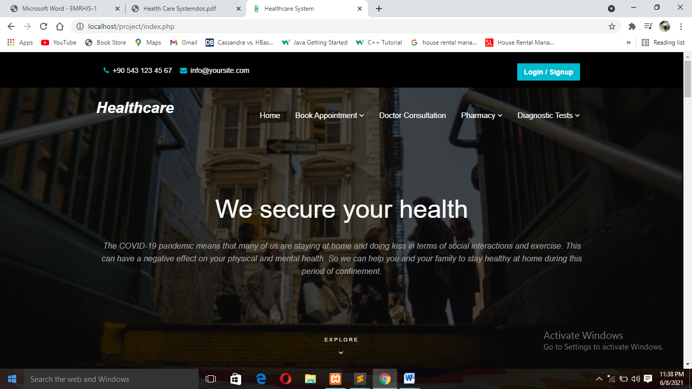

1. **Doctor Consultation & Book Appointment**

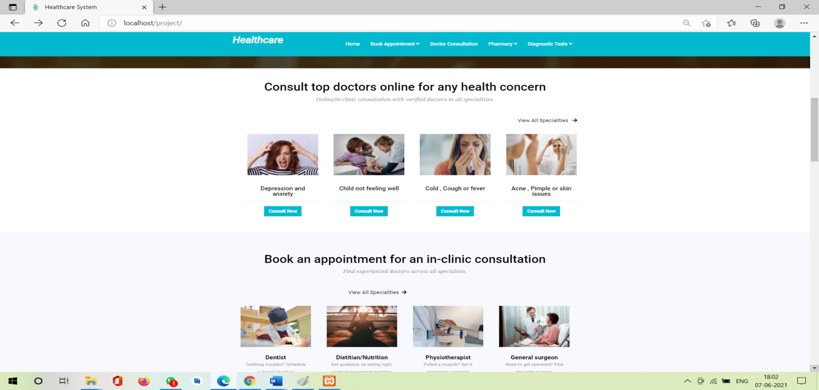

1. **Product and Health Packages**

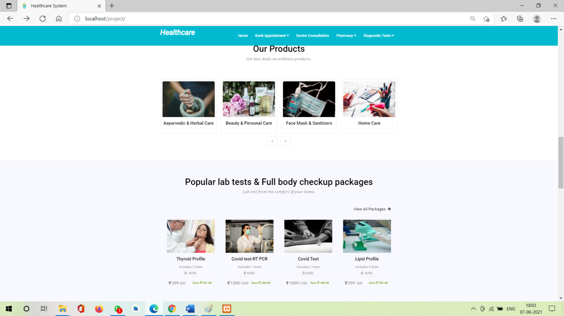

1. **Lab Tests**

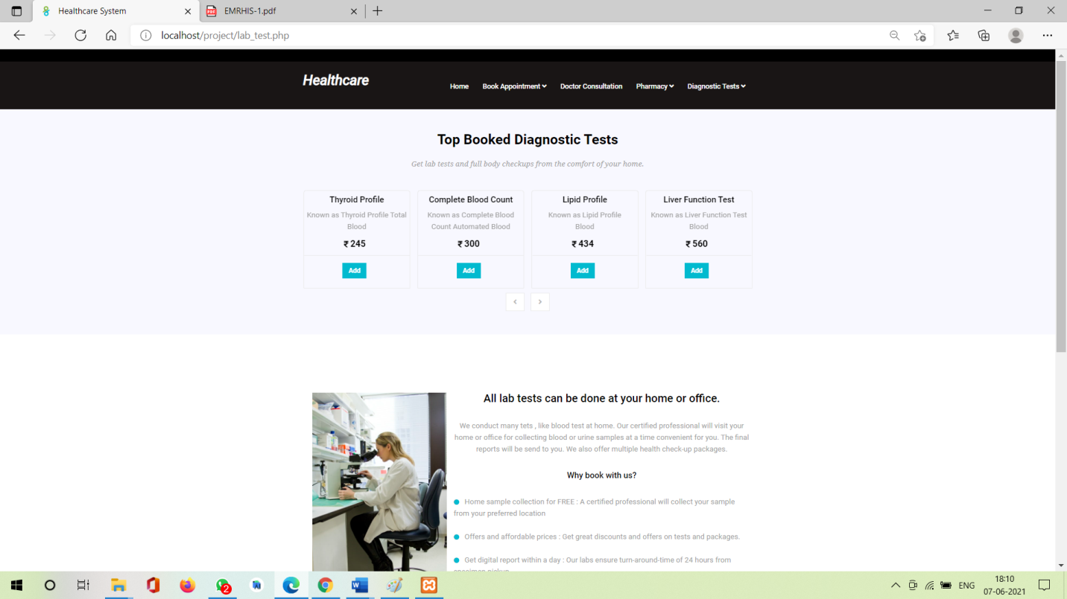

1. **Un-authorized Profile Dashboard**

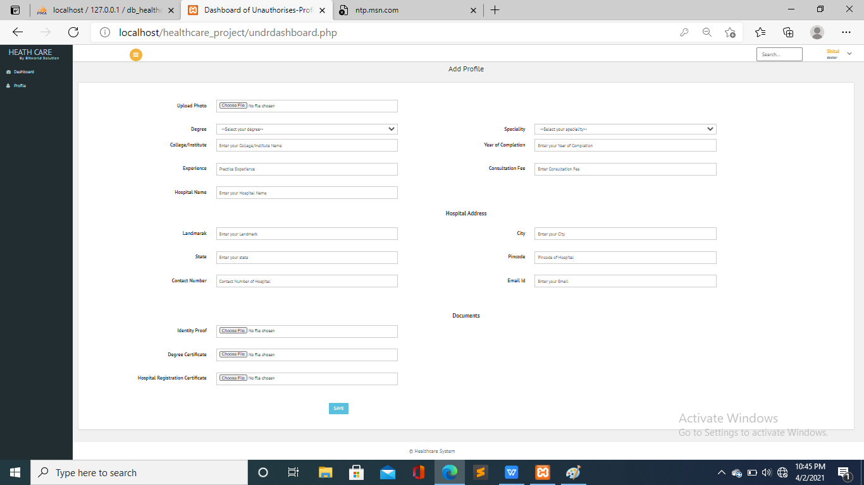

1. **Update Profile**

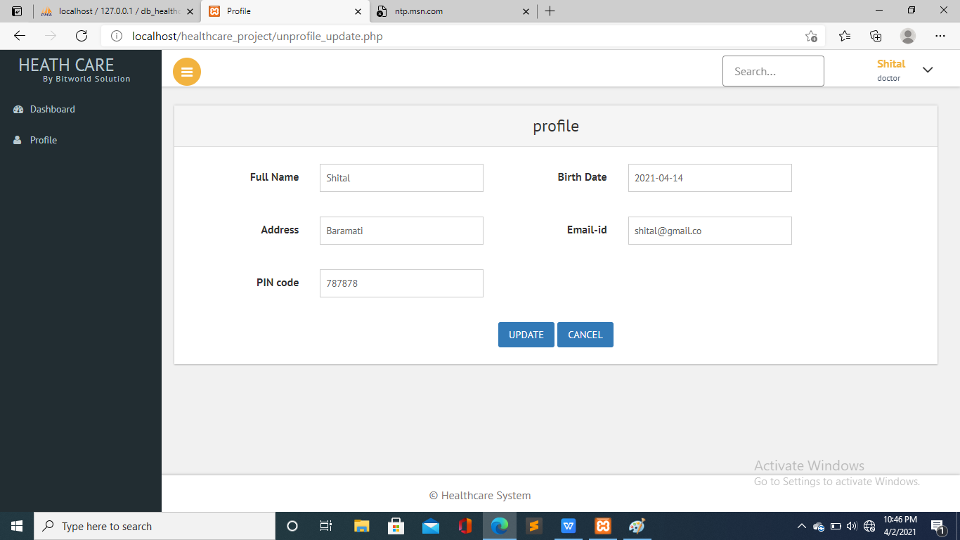

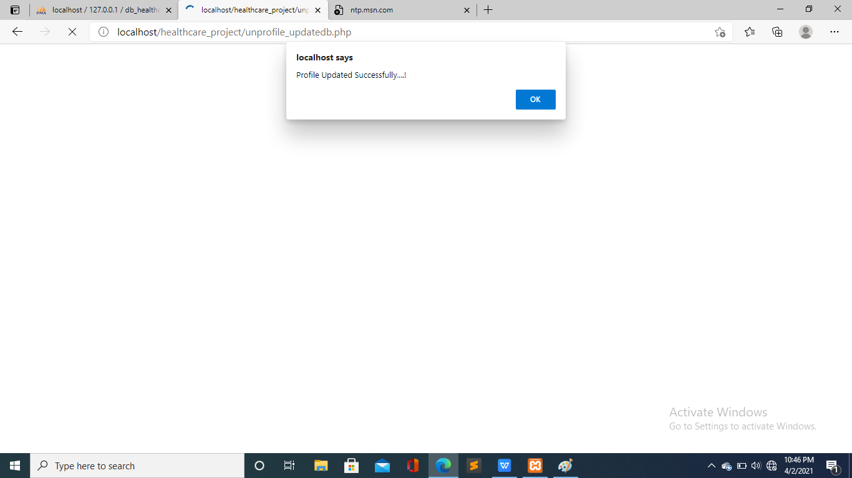

**Chapter 11**

**Annexure II**

**THANK YOU……!**